September 18, 2019

Dear Friends of Pennsylvania FFA Alumni:
“Make Your Mark” is the theme for the Pennsylvania FFA this year. Over the past thirteen years, the Pennsylvania FFA Alumni Association has worked diligently to provide 4,501 Pennsylvania FFA members the first step in a student’s success in this organization, which is providing them with a National Blue and Corn Gold corduroy jacket. As FFA alumni across the nation know, the blue and gold jacket provides a tremendous amount of pride as well as the unlimited opportunities that are made available for each and every student, helping them MAKE THEIR MARK in the organization.
As an alumni organization, we hope to present 400 students with jackets at the 2020 Mid-Winter Convention, which will take place in conjunction with the Pennsylvania State Farm Show. In order to reach our goal, we are asking for your help. For $60 you could sponsor a jacket for a first year FFA member. If you are interested, you may send a check, payable to Pennsylvania FFA Alumni Association, c/o Krista Pontius, 405 East Sunbury Street, Millerstown, PA 17062. Please note that this is a state-wide, competitive program. If you are interested in sponsoring an individual student or chapter, we would ask that you send your sponsorship directly to the chapter.
We invite you to join us at 103rd Pennsylvania Farm Show on January 6, 2020. The Mid-Winter Convention will begin at 2 PM in the New Holland Large Arena where we will witness the conferring of the coveted Keystone FFA Degrees, watch the announcement of the stars across Pennsylvania and stand in awe as hopefully 400 first year members create a sea of blue and gold as they zip their National Blue and Corn Gold corduroy jacket for the first time. As alumni, we know the tremendous amount of opportunities that lay before each of these fledgling FFA members and the excitement of becoming a part of this life-changing organization.

The Pennsylvania FFA Alumni secures the promise of the FFA mission and agricultural education by creating an environment where people and communities can develop their potential for premier leadership, personal growth, and career success. Thank you for considering this opportunity to help a young FFA member open the door to the unlimited possibilities of this tremendous organization! Feel free to contact me at the above information or kpontius@greenwoodsd.org if you have any questions about the First Year Member Jacket Program or the Pennsylvania FFA Alumni Association.
Sincerely,
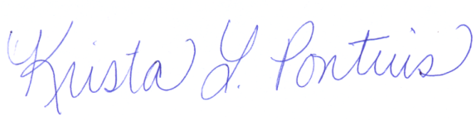

Krista L. Pontius
Pennsylvania FFA Alumni Association
First Year Member Jacket Campaign Chairperson

