FFA Foundation Funding Request:
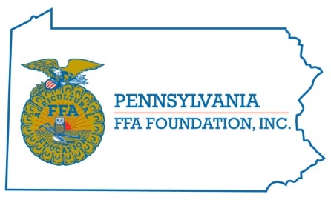
Organization Name:
Address:
City/State/Zip:
Contact Person:
Phone:
Email:

Brief description of Organization/Purpose/Program:

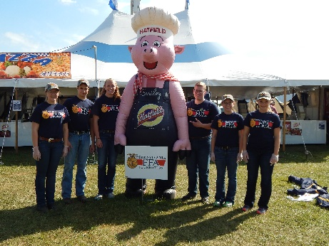
Amount Requested: ___________________________

Enclose the Following:
- Current Operating Budget Summary
- Budget Summary for the Proposed Project
- Other Sources/Amounts of Funding for Project
- Current Officer/Board Listing
- Cover Letter explaining
  - the need for funding
  - how the program meets the mission of the PA FFA Foundation (The mission of the PA FFA Foundation is to secure resources for the future of agriculture education and student leader development.

Date Submitted: ________________
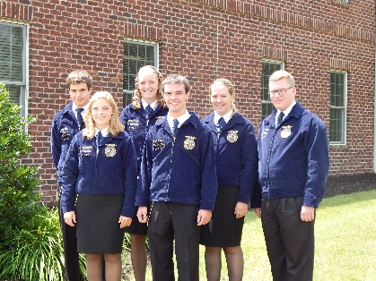
Due Date: January 1/April 1/July 1/ October 1

Email or Mail your Request to Sarah Sparks, Foundation Executive Director:
P.O. Box 157, East Berlin, PA 17316; ssparks@paffafoundation.org
*After the event please provide a summary and impact report.

Maximum Requests:
Local Chapters: $1000
Regional Chapters: $2500
State Association: $175,000

