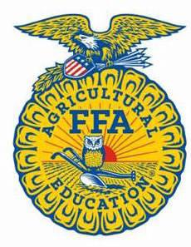
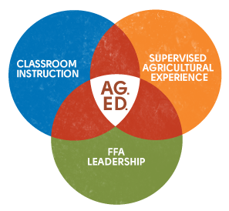
PA FFA Safe Tractor Driving
Career Development Event

Chairperson Information
CDE Chairperson | Curt Turner
Email | cturner@ccsd.cc
Best Contact Number | 570-204-9208
Contest Date/Times | June 9th and 10th 2026
Contest Location | June 9th (written exam on campus); June 10th (grass lot behind Ag Arena)
CDE Review Time | At the completion of the driving event on June 10th
CDE Review Location | CDE site

Basic CDE Guidelines
Event Type: Individual/Team | # of Team Members:
Individual Materials List  - Appropriate attire (see below)  - All completed forms (see below)  - Pencil | Group Materials List
Attire  - June 9th: official dress for written exam  - June 10th: must wear long pants and work boots (sneakers or open toed shoes are not permitted) for the driving events | CDE At-A-Glance  - Tractor inspection  - Two wheeled manure spreader event driving course  - Four wheeled wagon event driving course  - Written Exam  - Tractor tools/parts identification exam
Pre-State CDE Expectations
- Must have completed a tractor safety certification program
- Must have prior experience with tractors and equipment
- Must have been approved by the regional coordinator
- Only 4 participants per region (no trading of participants between regions)
- Participants must complete an entry and waiver form to register for activities week
CDE Changes from Previous Years?
- Regional coordinator verification
- Engine parts and tools identification
- Tractor safety certificate verification
- Entry form and waiver form required for Activities Week registration

CDE Rules
CDE Component | Points | Component Description
Causes for Disqualification:
Tie-breaker:

Resources

