# PA FFA Meats

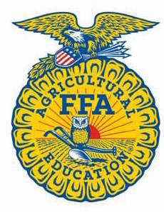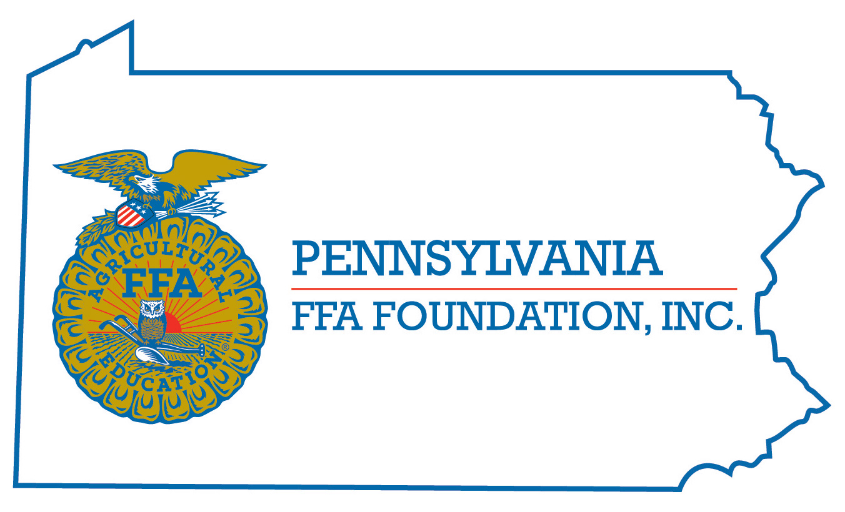

**Career Development Event**

***Chairperson Information***

|  |  |
| --- | --- |
| **CDE Chairperson** | Dylan Clark 2025 |
| **Email** | dclark@wasd.school |
| **Best Contact Number** | 724-371-7824 |
| **Contest Date/Times** | Tuesday 1:30 pm at PSU Meats Lab (Exam and Team Activities)  Wednesday 7:30 am on bus to Bierly’s Meat Market, Will return to PSU Meats lab for ID following carcass judging. |
| **Contest Location** | Meats Lab at PSU and Bierly’s Meat Market in Spring Mills |
| **CDE Review Time** | After all students are finished on Wednesday |
| **CDE Review Location** | PSU Meats Lab |

***Basic CDE Guidelines***

|  |  |
| --- | --- |
| **Event Type:** Individual/Team | **# of Team Members:** 4 members per team. |
| Individual Materials List   * Members need clip board, clean white paper, pencil and simple calculator (no memory or formulas) * White frock for cooler (Wednesday) * Hair Nets (Wednesday) * Hard Hats (Wednesday) | Group Materials List   * Same as individual * Team Events can be Marketing of carcasses, Identifying muscles in retail cuts or Carcass pricing |
| Attire   * Official dress on Tuesday only * Wednesday: No Official Dress Required! Hat, Long pants, boots/sneakers and sweatshirt for cooler work.   No Open Toed Shoes. Students will be required to wear Frocks, hard hats and hair nets in cooler. | CDE At-A-Glance (List of major components)   * General Knowledge * Formulation problem (Pearson square) * Yield and Quality grading of carcasses * Placing of primal or retail cuts * Retail cuts identification * Team Event |
| Pre-State CDE Expectations  **Students should be able to:**  Complete a Pearson Square Calculation  Fill out the Yield and Quality Grade Scorecard  Identify retail cuts and complete the score sheet  NOTE: Lamb carcasses and pork carcasses will NOT be included in the event. | |
| CDE Changes from Previous Years?   * Chairperson | |

***CDE Rules***

|  |  |  |
| --- | --- | --- |
| **CDE Component** | **Points** | **Component Description** |
| Identify Retail cuts (30 or 40) | 7 points per cut depending on cut availability | See National Meats event information |
| Yield-grade beef carcasses | 10 points per carcass | 4 carcasses |
| Quality-grade beef carcasses | 10 points per carcass | 4 carcasses |
| Place carcasses and retail cuts classes | 50 pts. Per class | 3 classes |
| **Causes for Disqualification: Cell phone use, talking, students not properly dressed will not be allowed in the slaughter house as this facility is USDA inspected. Long pants and boots/sneakers are required!** | | |
| **Tie-breaker:** Retail cuts | | |

***Resources***

|  |
| --- |
| National FFA Meats CDE materials:  <https://www.ffa.org/SiteCollectionDocuments/cde_meats_2012.pdf>  Exam reference: CEV, Meats Science and Food Safety:  <http://www.cevmultimedia.com/index.php?p=product&id=1595>  Search: Retail Meat Cuts ID and you will find several sites for practice retail cuts ID and judging.  Search: Meats Formulation problems to find several sample formulation problems. |