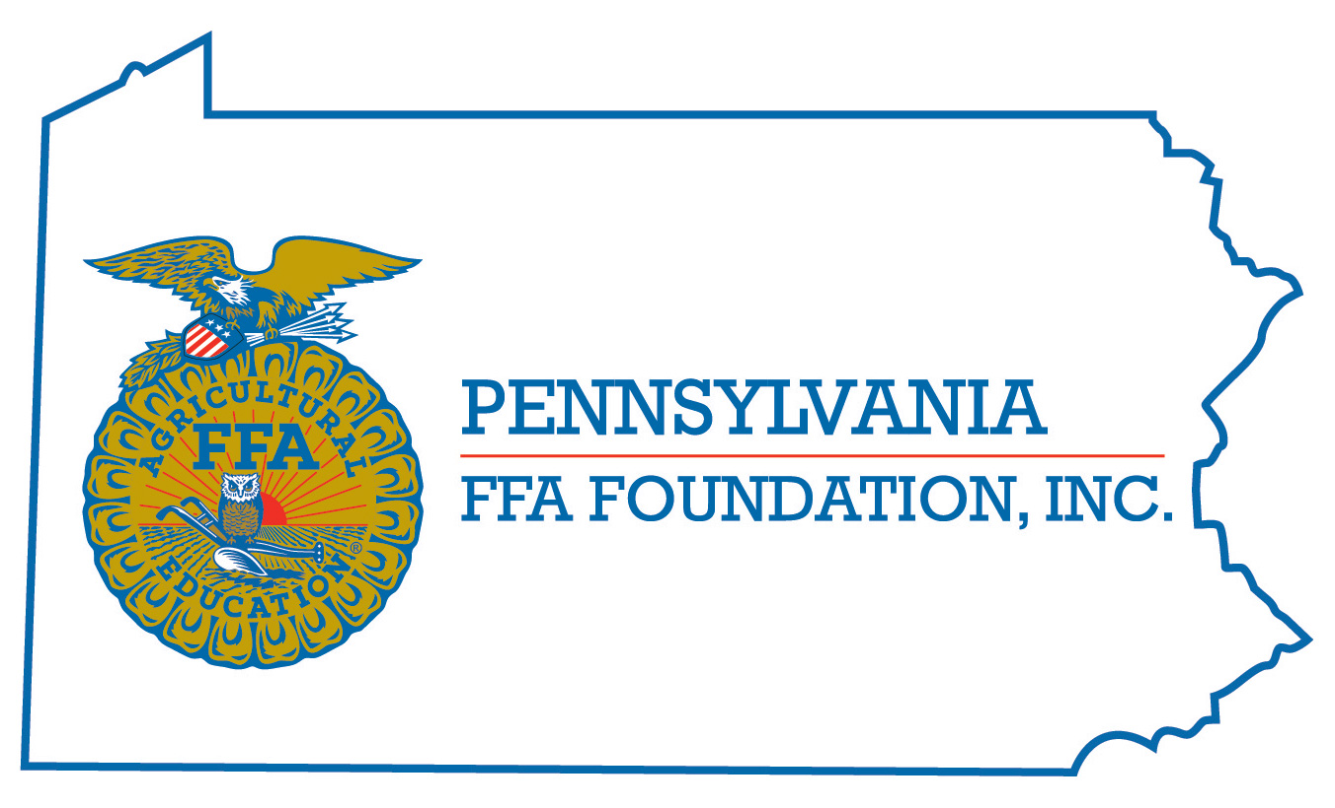
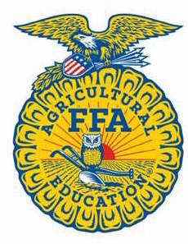
PA FFA Poultry Evaluation
Career Development Event

Chairperson Information
CDE Chairperson | Neil Fellenbaum
Email | neil.fellenbaum@pennmanor.net
Best Contact Number | 717-872-9520 x1590
Contest Date/Times | Tuesday/Wednesday
Contest Location | Tues: Location TBD on campus Wed: Ag Arena Holding Barn
CDE Review Time | 12:00 Wednesday
CDE Review Location | Ag Arena Holding Barn

Basic CDE Guidelines
Event Type: Individual/Team (BOTH) | # of Team Members: 4, all four individual scores count towards team score
Individual Materials List  - Clipboard  - Calculator (non-programmable)  - 2 Pencils | Group Materials List  - Same as individual
Attire  - Tuesday Test/Team Event—Official FFA Dress (5 point deduction from written test for each component of official dress missing)  - Wednesday—Official Dress (10 point deduction in reasons scores for no official dress), closed toe shoes | CDE At-A-Glance (List of major components)  - Live bird (hen and broiler) evaluation  - Interior and Exterior Egg Grading  - Carcass and parts grading  - Carcass placing class  - Ready to Cook Poultry Product evaluation (bone-in/boneless)  - Parts ID  - Written Test  - Team Event  - Two sets of reasons on classes chosen day of contest (hens OR broilers, and carcass placing)
Pre-State CDE Expectations
- No Contact with live birds 48 hours prior to event for biosecurity reasons
CDE Changes from Previous Years?
- Contest will always follow current National FFA CDE handbook found HERE.

CDE Rules
CDE Component | Points | Component Description
Class 1: Market Broiler Placing | 50 | Place four market broilers. Participants may handle birds, but not take them out of the cage. *possible reasons class
Class 2: Past Production Hens | 50 | Place four hens on egg production characteristics. Participants may handle birds outside of the cage.  *possible reasons class
Class 3: Ready-To-Cook (RTC) Carcass/Part Grading | 50 | Ten chicken and/or turkey carcasses and/or parts graded based on USDA factors. Grades are A, B, C, or NG (non-gradable)
Class 4: RTC Carcass Placing | 50 | Place 4 Chicken or Turkey Carcasses  *reasons class
Class 5A/B: TWO sets of Oral Reasons on Class 1 or 2 AND 4 | 100 | Presentation of Oral Reasons. Ten minutes prep time given, two minutes to present.
Class 6: Interior Egg Grading | 50 | Grading of 10 white shell eggs based on USDA interior egg grading factors. Grades are AA, A, B, and Loss.
Class 7: Exterior Egg Grading | 50 | Grading of 15 white or brown shell eggs based on USDA exterior grading factors. Grades are AA/A, B, and NG (non-gradable)
Class 8: Written Factors for Class 7 | 50 | Contestants will identify defects on eggs in class 8 from a list on scorecard. No Defect is an option.
Class 9: Boneless Further Processed Poultry Product Evaluation | 50 | Contestants will evaluate 10 samples of boneless further processed product (nuggets, tenders, patties). Defects will be selected from score card. No Defect is an option.
Class 10: Bone-In Further Processed Poultry Product Evaluation | 50 | Contestants will evaluate 10 samples of bone-in further processed product (precooked bone in poultry product). Defects will be selected from score card. No Defect is an option.
Class 11: Poultry Parts ID | 50 | Contestants will identify 10 poultry parts.
Class 12: Poultry Management Written Exam | 100 | 30 item multiple choice test, at least 5 will be math problems.
Team Event | 150 | Team members will be asked to complete one or more performance-based practicums. The  scores will be derived from responses to an appropriate number of questions including  calculations. Team members may be asked to utilize provided materials in their responses.
Causes for Disqualification:
- Cell phone usage
- Talking to other contestants during contest
- Handling product that is not to be handled
Tie-breaker:
- INDIVIDUAL-Total placing classes score, written test, oral reasons scores
- TEAM-Team Activity total, combined written exam, combined further processed products

Resources
Everything you need is in the Poultry Science Manual for National FFA Career Development Events. Can be ordered from the National FFA Core Catalog.

Tests and team event examples located at
https://www.ffa.org/participate/poultry/

