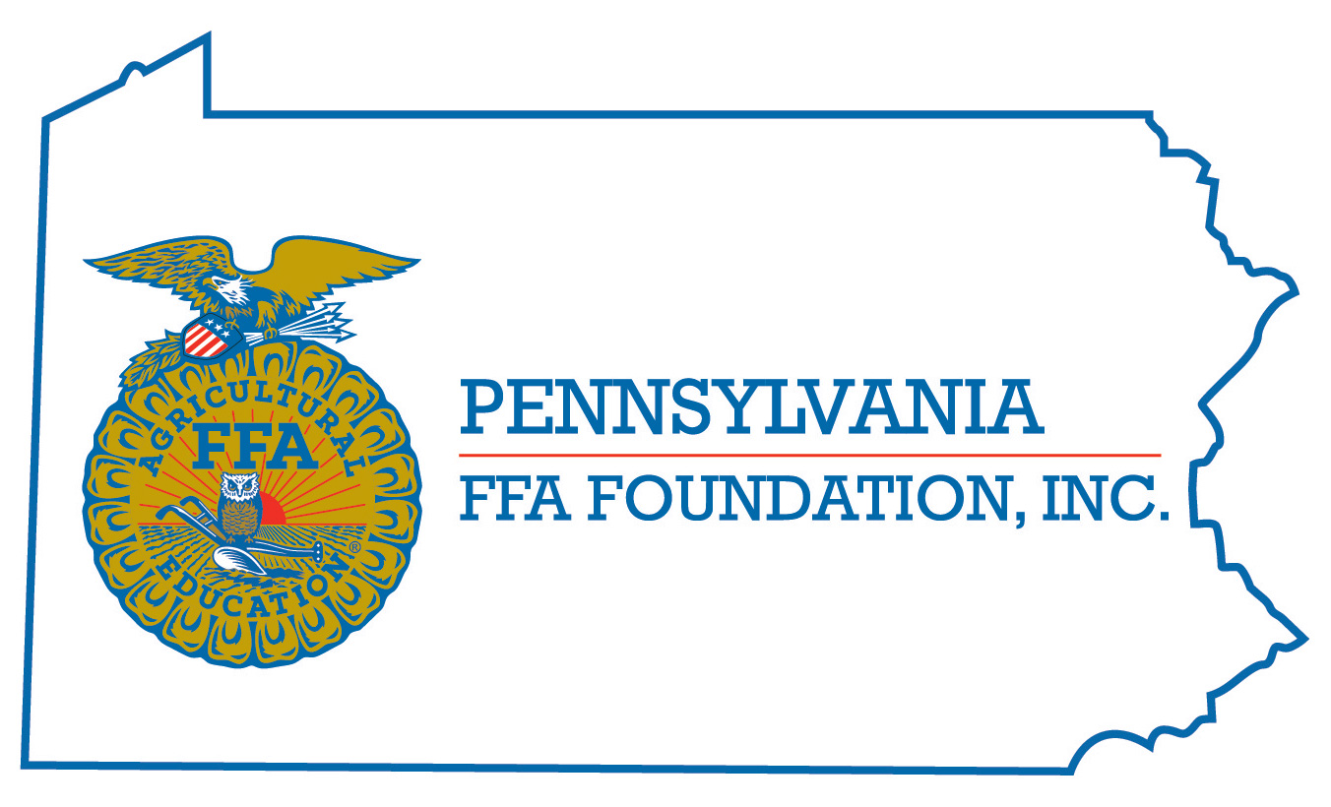
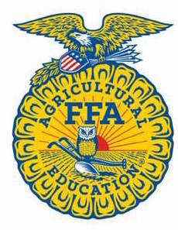
FFA Knowledge CDE
Career Development Event

Chairperson Information
CDE Chairperson | Kelly M. Bier
Email | Kelly.bier@ship.k12.pa.us
Best Contact Number | Cell – 717-860-5843
Contest Date/Times | Wednesday at 8:15 am
Contest Location | TBA
CDE Review Time | At the conclusion of the event
CDE Review Location | TBA

Basic CDE Guidelines
Event Type: Team | # of Team Members: 3 in 7th, 8th, or 9th grade  Can compete more than once, if they are not on a winning team
Individual Materials List  - The CDE will consist of a 75 question multiple choice individual test  - Questions will come from the FFA Student Handbook, , Official FFA Manual, www.ffa.org and www.paffa.org  - See the FFA Knowledge Study Guide | Group Materials List  - The top 8 teams will come back for Jeopardy rounds.  - The team scores on the tests will be ranked to determine the seeds for the Jeopardy rounds.  - Each round will consist of a Jeopardy round, and a Final Jeopardy round.  - Each team will get 10 seconds to answer the question once they have buzzed in.  - Contestants must wait to buzz in until after the question is finished being read.  - Contestant must wait to be recognized.  - There will be no points deducted for wrong answers.  - The team can discuss the question before giving a team answer.  - The final score of the Jeopardy round will be used to determine team rank if the team does not move forward in the bracket.
Attire  - Official Dress – Please refer to guidelines set by National FFA | CDE At-A-Glance (List of major components)  - Individual Test – 75 questions  - Single Elimination Jeopardy Rounds
Pre-State CDE Expectations
- Complete the Study Guide posted on the PA FFA Website to help to study for the event.
CDE Changes from Previous Years
- None

CDE Rules
CDE Component | Points | Component Description
Written Test | 75 | Multiple Choice & Matching Questions based on the resources, and Study Guide
Jeopardy | Varies on amount earned | Teams of three students will compete against another team from a different school. They will participate in a final Jeopardy round, and will get to wager the amount of points that they wish. If they win, then they will advance in the bracket to the next level.
Causes for Disqualification: Not wearing appropriate official dress. Using cell phones during the event.
Tiebreaker: Ties on the test will be broken with predetermined test questions.

Resources
www.ffa.org
www.paffa.org
Study Guide posted on the PA FFA Website
Sample Jeopardy Round posted on the PA FFA Website
FFA Student Handbook
Official FFA Manual

Jeopardy Round Topics
- Historical Figures
- LDE’s
- National FFA Officers
- New Farmers of America
- PA Ag Ed Family (Alumni, PAAE, Association, Foundation)
- PA FFA Structure (Regions, By-Laws and Constitution, Policy, etc.)
- Proficiency Awards
- SAE For All
- State FFA Officers
- What’s the Month
- Who’s Who

- Acronyms
- CDE’s
- Chapter Officer Duties
- Chapter Officer Symbols
- Conduct of Chapter Meetings
- Conferences and Conventions
- FFA Basics - Mission, Vision, Motto, Code of Conduct
- FFA Awards
- FFA Creed
- FFA Degrees
- FFA Emblem
- FFA History: 1950-2000
- FFA History: Post 2000
- FFA History: Pre 1950
- FFA Jacket
- FFA Statistics

