PA FFA Food Science and Technology
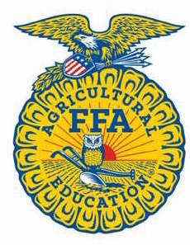
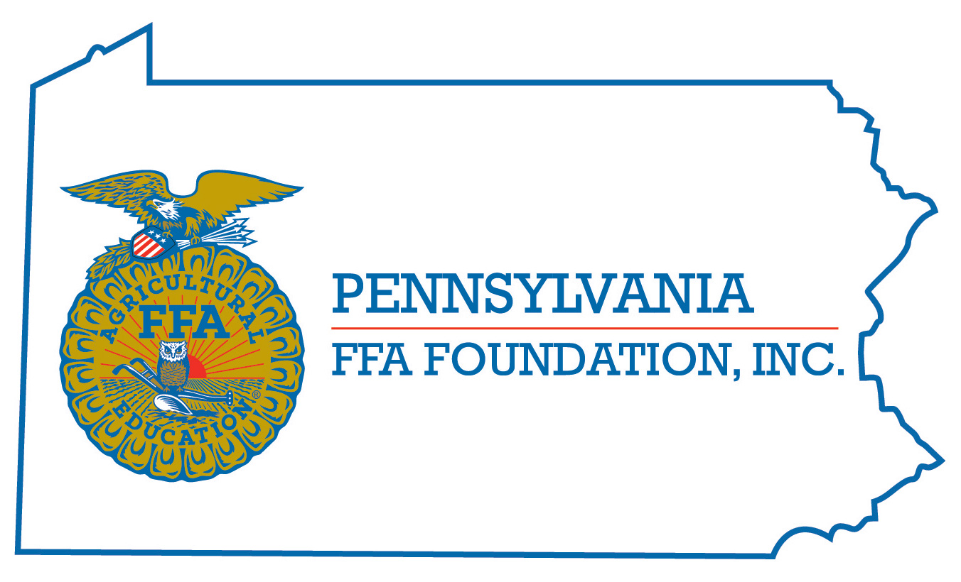
Career Development Event

Chairperson Information
CDE Chairperson | Adam Serfass and Jeremy Deysher
Email | A_serfass@conradweiser.org jdeysher@ovsdpa.org
Best Contact Number | 610-693-8542
Contest Date/Times | At FFA State Convention: Tuesday 2pm-5pm, Wednesday 8:30am–2pm
Contest Location | 252 Food Science Building and/or 11/13 ASI Building
CDE Review Time | Immediately following contest
CDE Review Location | 252 Food Science Building

Basic CDE Guidelines – Follows the National Guideline
Event Type: Individual/Team | # of Team Members: 4
Individual Materials List  - Clipboard  - Sharpened #2 pencils  - Non-programmable calculator | Group Materials List  - All necessary materials will be provided by the CDE committee
Attire  - Official Dress Required | CDE At-A-Glance (List of major components)  - Team Product Development  - Sensory Analysis (Triangle test, aroma ID)  - Customer Inquiry  - Food Safety and Sanitation - Team  - General Knowledge Test
Pre-State CDE Expectations
- Identify any known food allergies and contact CDE chairperson
- Review test bank questions available on the PA FFA website
- Practice team product development scenarios
- Become familiar with food science sensory analysis tests
CDE Changes from Previous Years?
- This CDE conforms to all components of the current National Career Development Event

CDE Rules
CDE Component | Points | Component Description
General Knowledge Test | 150 | The objective questions administered during the food science and technology examination will be designed to determine each team member’s understanding of the basic principles of food science and technology. The test will be primarily based on the list of references at the end of this chapter. Team members will work individually to answer each of the 50 questions. Each person will have 60 minutes to complete the examination. Each question will be worth 3 points, for a total of 150 points.
Practicum’s (Customer Inquiry and Food Safety/Sanitation) | 105 | Customer Inquiry- Each participant will be given five scenarios representing general consumer inquiries. Participants must determine if the consumer inquiry reflects a quality or safety issue and determine if it is a biological, chemical or physical concern or hazard. (25 points)  Food Safety/Sanitation- Each team will be given a situation (e.g., photos, videos, written scenarios, live demonstrations or a combination). The team will work together to evaluate the situation and complete a safety/sanitation report evaluation that will include observations, degree  of concern and recommendations/corrective actions. from the list of problems provided. (80 points)
Sensory Evaluation: Triangle Tests, Problem Solving/Math Practicum, Aroma Identification | 65 | Triangle Tests- Four different triangle tests will be conducted. Participants are expected to identify the different samples through flavor, aroma, visual cues and/or textural differences. Answers will be given on the sheet provided. No list will be provided for this segment of the practicum. Each test is worth 5 points.  Problem Solving/Math Practicum- Participants will complete a problem solving/math practicum.  Aromas- Each participant will be asked to identify four different aromas from vials provided at each station and record the answer on the sheet provided. A list of potential aromas will be provided to each person. Each sample is worth 5 points.
Team Product Development Project | 400 | Each team will receive a product development scenario describing the need for a new or redesigned product that appeals to a potential market segment. The team’s task will be to design a new food product or reformulate an existing product based on information contained within the product development scenario. The team will be responsible for understanding and using the following concepts:  a. Formulation of product to meet specified requirements.  b. Package design and labeling requirements to reflect the developed product.  c. Nutritional fact development.  d. Production and packaging equipment.  e. Quality control and safety programs, i.e., good manufacturing practices (GMP) and hazard analysis critical control points (HACCP). f. Formulation and costing (ingredient, packaging, etc.).  g. Current food trends.  h. Market segments.  Each team will be provided with packaging materials, ingredients and necessary ingredient information in order to develop, label and package a product.  The team will have 60 minutes to respond to the product development scenario and reformulate or develop a product, calculate a nutritional label, develop the ingredient statement and information panel and develop the front or principle display panel to reflect the new product.  After this time period, each team member will contribute to a ten minute oral presentation delivered to a panel of judges. No electronic media will be used in the presentation.  Following the presentation there will be a ten minute question and answer period with the judges in which each team member is expected to contribute. All materials will be collected after the presentation.
Causes for Disqualification: Any participant in possession of an electronic device, except a calculator, in the event area is subject to disqualification.
Tie-breaker:

A. Team: Should a tie occur in the overall team placing, the tie will be broken by the highest team product development project score. If this score does not break the tie, then the highest number of total points earned from the objective test (adding all four team member scores) will break the tie. If a third tiebreaker is needed, the total points earned by the team in the food safety and quality practicum will be used.

B. Individual: To identify the high individual for this event in case of a tie, the highest objective test score will be used as the first tiebreaker, followed by the highest food safety and quality practicum score as the second tiebreaker.

Resources
National FFA Core Catalog—CDE Questions and Answers http://shop.ffa.org/cde-qas-c1413.aspx

Mehas and Rodgers, 5th Edition, 2006. Kay Yockey Mehas and Sharon Lesley Rodgers, Glencoe/McGraw, New York.

Food Science and Safety, 2nd Edition, 2004, George J. Seperich, Pearson Publishers

Principles of Food Sanitation, 5th Edition, 2006, Norman G. Marriott and Robert B. Gravani, Springer Science + Business Media, Inc.

Institute of Food Technology website, http://www.ift.org

USDA Food Safety and Inspection Service website, http://www.fsis.usda.gov

Penn State Kitchen Chemistry: Experiments, resources and materials for educators and students, http://foodscience.psu.edu/public/kitchen-chemistry

Food Safety Education, http://www.fsis.usda.gov/food_safety_education/for_kids_&_teens/ index.asp

Partnership for Food Safety Education, http://www.fightbac.org

FoodSafety.gov, http://www.foodsafety.gov

