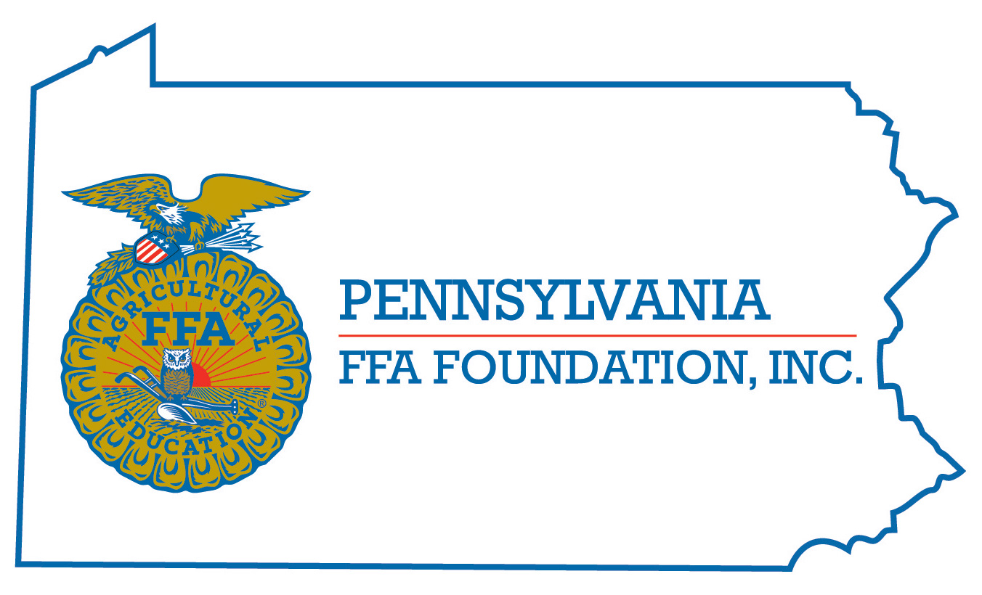
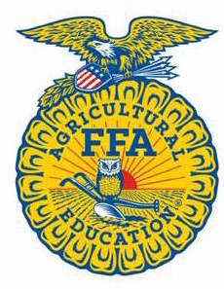
PA FFA Wildlife
In-Person
Career Development Event

Chairperson Information
CDE Chairperson | Gretchen Dingman
Email | gad@tvdawgs.net
Best Contact Number | 570-660-6800
Contest Date/Times | June 14th at 9:00 A.M.
Contest Location | Forestry Resources Building
CDE Review Time | If there are questions please call my cell.
CDE Review Location | N/A

Basic In-Person CDE Guidelines
Event Type: Individual/Team | # of Team Members: 0
Individual Materials List  - 2 - #2 Pencils and Eraser  - Clipboard  - Global Positioning System (GPS): The minimum requirements for GPS will be the Garmin eTrex receiver or compatible. Position accuracy WAAS enabled three meters, 20 routes | Group Materials List  - N/A
Attire  - Casual School Appropriate Dress | CDE At-A-Glance (List of major components)  - Wildlife Test, Bird ID, Mammal ID, Bird Call ID, Foods ID, and Signs
Pre-State CDE Expectations
- All students with an interest in PA Wildlife are encouraged to participate.
CDE Changes from Previous Years?
- Added a few Identification to lists.
- Added a GPS Practicum to align with National FFA ENR CDE. In 2023, this will be an educational station, with the hopes of scoring it in 2024.

CDE In person Rules
CDE Component | Points | Component Description
Wildlife Test | 100 | This part includes 50 comprehensive questions on wildlife conservation and management.
Bird Identification | 40 | Students will identify 40 different birds found in Pennsylvania.
Foods Identification | 20 | Students will identify 20 different foods that Pennsylvania wildlife commonly eat.
Wildlife Signs | 20 | Students will identify 20 different signs of wildlife
Mammal Identification | 20 | Students will identify 20 different mammals found in Pennsylvania.
Bird Calls | 20 | Students will identify 20 different bird calls from birds in Pennsylvania.
Wildlife Tracks | 20 | Students will identify 20 different wildlife tracks
Environmental Analysis | 40 | Student will complete an environmental analysis, identifying wildlife species, non-living components, construct a food web, identify stage of succession and determine if this is a suitable habit – why or why not.
Non-native / introduced species | 20 | Students will identify 20 introduced / non-native species.
Causes for Disqualification: Cheating and any other rule specified by the PA FFA that apply to all CDE’s.
Tie-breaker: Bird Calls then the Wildlife Test then Foods Identification if needed.

Resources
PA Game Commission “Wildlife Note Series”
PA Game Commission “A Digest of Hunting & Trapping Regulations”
PA Game Commission “Mammals of Pennsylvania” & PA Game Commission “Birds of Pennsylvania”
PA Game Commission website
- Current Issues facing Game Commission Properties (mineral right, wind turbines etc.)
Textbook - Delmar “Wildlife and Natural Resource Management”
Invite Birds to Your Home - Conservation Plantings for the Northeast, Soil Conservation Service
Shrubs and Vines for Northeastern Wildlife, U. S. Forest Service;
Peterson Field Guide to Trees and Shrubs;
The Audubon Society, Field Guide to North American Trees - Eastern Region.
Nasco Field Guide to Tracks of North American Wildlife
Peterson Field Guide to Animal Tracks
Guide to Mammals of PA by Joseph Merritt
Tracking and the Art of Seeing by Paul Rezendes
Audubon App for bird calls

