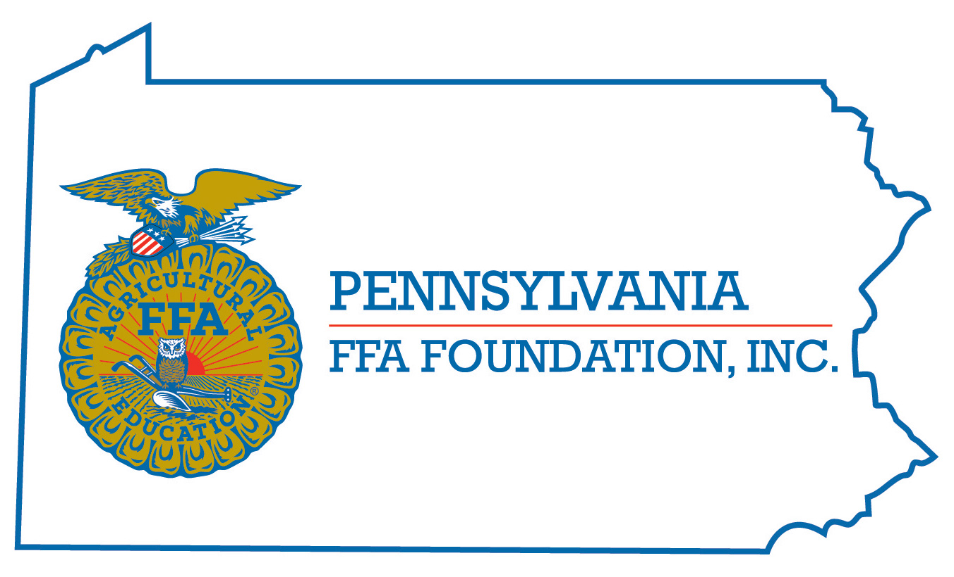
PA FFA Milk Quality and Products
Career Development Event

Chairperson Information
CDE Chairperson | Nicole Guise
Email | nguise@millsd.us
Best Contact Number | 717-650-7110
Contest Date/Times | Tuesday 2 pm and Wednesday 9 am
Contest Location | Food Science Building
CDE Review Time
CDE Review Location

Basic CDE Guidelines
Event Type: Individual/Team | # of Team Members: 4 ONLY
Individual Materials List  - Tuesday-Pencil & Non-programmable calculator  - Wednesday-Pencil, Clipboard, Bottle water/apple/apple juice | Group Materials List  - Not applicable
Attire  Tuesday-Official Dress  Wednesday-School appropriate attire, must have jeans or long pants, clean/closed toe shoes and no jewelry or perfume on | CDE At-A-Glance (List of major components)  - Written test-60 questions (40 Minutes)  - Problem Solving Test (40 Minutes)  - Team Event (varied do to activities)  - Milk Off flavors (20 Minutes)  - Fat Content (20 Minutes)  - Cheese ID/Cheese Matrix (20 Minutes)  - CMT (Mastitis Test) (20 Minutes)
Pre-State CDE Expectations
Team Event-To perform well in the Team Event portion of the Dairy Foods Career Development Event team members should be familiar with provisions of the Grade “A” Pasteurized Milk Ordinance that contains rules describing the acceptability of raw milk for pasteurization. These regulations are available at www.fda.gov.

Individuals should know how to read and fill out a scantron sheet. Students should have the defects scores, cheese matrix and the CMT chart scores memorized

CDE Changes from Previous Years? Following the 2017-2021 rules and stations

CDE Rules
CDE Component | Points | Component Description
Written Test | 120 | 60 Multiple choice questions (30 Production/30 Market questions)
Problem Solving Test | 100 | 10-20 critical-thinking, multiple choice questions. Topics may include, but are not limited to: 1. Decisions about the quality and acceptability of milk.  2. Calculations of the value of milk and components of milk.  3. Decisions about components of milk and milk products (including processing procedures).  4. Decisions about the use of chemicals in cleaning and sanitizing operations
Team Event | 100 | Teams members will work together to determine producer milk acceptability based on a test sample given.  Examples of acceptability tests include:  A. Recent producer history  B. Percent TA (acidity)  C. DMC (Direct Microscopic Somatic Cell Count)  D. SPC (Standard Plate Count)  E. PI count (Preliminary Incubation Count)  F. Antibiotic screening test  G. Sample freezing point Teams will present their solution and improvement recommendations to a panel of judges.
Practicum | 360 | Cheese Identification (20 Minutes) - 100 points  - Ten cheese samples for identification will be selected from the list National Milk Quality CDE Cheese list.  - Cubes of the cheeses will be available for tasting. Note: More than one sample of a given cheese may be used.  - In addition to identifying cheese samples, participants will classify characteristics of identified cheeses using the following matrix. Participants will have seven characteristics to select based on the five identified cheese samples. An example cheese characteristic problem can be found in the National Milk Quality CDE handbook.  Product Identification (20 minutes) - 100 points  - Ten samples of milk/nonmilk products will be identified according to their content of milk fat.  - The following products may be included among the samples:  Dairy Products: nonfat (skim) milk (.05%), lowfat milk (1.0%), reduced fat milk (2%), milk (3.25%), half and half (10.5%), butter (80%), sour cream (18%), flavored milk (6.05%-3.25%) light whipped cream (30%), heavy cream (36%)  Non-Dairy Products: Margarine, non-dairy creamer, non-dairy sour cream, non-dairy milk, non-dairy flavored beverage and non-dairy whipped topping all of these are to be categorized as non-dairy fat.  nonfat (skim) milk, reduced fat milk (2%), milk (3.3%), half and half (10.5%), coffee cream (18%) and whipping cream (30%).  California Mastitis Test (20 minutes) - 40 points  - The California Mastitis Test will be scored using even numbers from 0 to 8 inclusive. (See National FFA Milk Quality CDE handbook for the Scoring Guide for the California Mastitis Test.)  - Five samples of milk will be evaluated for abnormality, using the California Mastitis Test method.  Milk Flavor Identification and Evaluation (20 minutes) - 120 points  - Ten milk samples will be scored on flavor (taste and odor) using the computerized scorecard. All samples of milk are prepared from pasteurized milk intended for table use and will score 1 to 10 (See Scoring Guide). Milk samples will be tempered to 60°F. Only those cups provided at the event may be used.  - Participants are to use whole numbers when scoring “Flavor” of milk and to check only the most serious defect in a sample even if more than one flavor is detected. If no defect is noted, participants should check, “No defect” and score as a ten (See Scoring Guide).  - Palette cleansers (e.g. apples or soda crackers) will be allowed for refreshing.
Causes for Disqualification: Talking during the contest (especially during Wednesday) Found cheating, Points will be deducted if students are not in official dress on Tuesday, DQ-not following dress code on Wednesday
Tie-breaker: If ties occur, the following events will be used in order to determine award recipients:
Team
1. Team activity
2. Milk identification total score of all team members.
3. Cheese identification score for all team scores.
Individual
1. Milk identification
2. Cheese identification
3. Product identification
4. Problem solving

Resources
National FFA Milk Quality 2017-2021 Handbook
Grade “A” Pasteurized Milk Ordinance that contains rules describing the acceptability of raw milk for pasteurization. These regulations are available at www.fda.gov
PA FFA Milk Quality Question Bank

