September 25, 2020

Dear Friends of Pennsylvania FFA Alumni:
“MORE” is the theme for the Pennsylvania FFA this year. Although 2020 has proven to be less of many things for our students, the FFA is committed to more: more opportunities, more experiences, more friendships, and more growth as individuals throughout this school year. Over the past fourteen years, the Pennsylvania FFA Alumni Association has worked diligently to provide 4,852 Pennsylvania FFA members the first step in a student’s success in this organization, which is providing them with a National Blue and Corn Gold corduroy jacket. As FFA alumni across the nation know, the blue and gold jacket provides a tremendous amount of pride as well as the unlimited opportunities that are made available for every student, helping them experience MORE within this life changing organization.
As an alumni organization, we hope to present 400 students with jackets this winter. To reach our goal, we are asking for your help. For $60 you can sponsor a jacket for a first year FFA member. If you are interested, you may send a check, payable to Pennsylvania FFA Alumni Association, c/o Krista Pontius, 405 East Sunbury Street, Millerstown, PA 17062. Please note that this is a state-wide, competitive program. If you are interested in sponsoring an individual student or chapter, we would ask that you send your sponsorship directly to the chapter.
Unfortunately, this year we will not have the opportunity to witness the sea of blue and gold at the Mid-Winter Convention; however as alumni, we know the tremendous amount of opportunities that lay before each of these fledgling FFA members and the excitement of becoming a part of this life-changing organization, so we will ensure that they are recognized for taking the first step on their ladder of agricultural education accomplishment.

The Pennsylvania FFA Alumni secures the promise of the FFA mission and agricultural education by creating an environment where people and communities can develop their potential for premier leadership, personal growth, and career success. Thank you for considering this opportunity to help a young FFA member open the door to the unlimited possibilities of this tremendous organization! Feel free to contact me at the above information or kpontius@greenwoodsd.org if you have any questions about the First Year Member Jacket Program or the Pennsylvania FFA Alumni Association.
Sincerely,
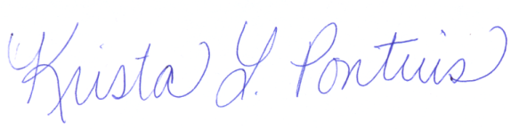

Krista L. Pontius
Pennsylvania FFA Alumni Association
First Year Member Jacket Campaign Chairperson

