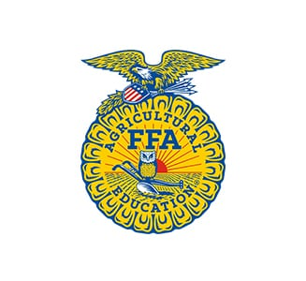
Pennsylvania FFA Association
2020 Agricultural Cooperation Establishes Success (ACES) Conference
#ACES2020 - “Set Sail”

Saturday Schedule (Feb. 8th, 15th, and 22nd)
- Lunch On Your Own
- *11:30am-12:30pm: Registration - PA Ballroom
- *12:40pm-1:00pm: Opening Ceremonies & Welcome - Commonwealth Ballroom
- 1:00pm-5:00pm: Teacher’s Workshops - PA Ballroom
- *1:00pm-5:00pm Small Group Workshops (SEE BACK)
- *5:00pm-6:00pm: Check Into Hotel Rooms - Sheraton Hotel
- *6:15pm - 7:45pm: Dinner Buffet - Commonwealth Ballroom
- **8:00pm-10:15pm: Social Time - Commonwealth Ballroom
- **10:20pm-10:40pm: Reflections - Commonwealth Ballroom
- 11:00pm: LIGHTS OUT - CURFEW

Sunday Schedule (Feb. 9th, 16th, and 23rd)
- ***7:30am-8:00am: Optional Time of Inspiration - Commonwealth Ballroom
- ***8:00am-10:30am: Breakfast and Activity - Commonwealth Ballroom
- ***10:30am: Remarks and Closing Ceremonies - Commonwealth Ballroom

Thank You For Setting Sail on Your Way to MAKING YOUR MARK!

Dress Code:
*Official Dress
** School-Appropriate Clothing
*** ACES T-Shirt

Small Group Workshop Rotations

Track 1: Maiden Voyage: (Freshman and Sophomore Members)

- Sailing Manners: Professionalism and FFA Etiquette (Elm)
- Staying Afloat: Responsibility and Record Keeping (Dogwood)
- Chart Your Course: Conversation Skills (Salon C)
- Know Your Destination: SMART Goals (Salon D)
- Why We Sail: FFA Mission and Motto (Salon E)

Track 2: Veteran Sailors: (Junior and Senior Members)

- From Hull to Upper Deck: 5 Levels of Leadership (Chestnut)
- Open Sails: Networking/Connections (Fir)
- Surveying the Horizon: Exploring Pennsylvania Agriculture (Hemlock)
- Full Speed Ahead: FFA and Your Future (Birch)
- Protecting the Treasure: Financial Responsibility (Ash)

