NEBRASKA
SAE
RECORD KEEPING
PROJECT

This example was provided by Randy Vlasin of Chase County High School
and modified by the Nebraska Agricultural Education Association (NAEA).

Sam Husker has both work experience and production enterprises. The following information relates to the SAE arrangements.
Description

Work Experience

Sam will be working part time at the General Ag. Supply Store. [Work hours will be on some weekends during the school year and three days per week during the summer months. Hours will not exceed thirty hours per week. Starting salary will be $5.75 per hour with work starting on April 6th. Sam will be paid every 2 weeks with health insurance provided. If progress is made on the job, a .25 per hour increase will be made, after 3 months. ] All information in brackets=Time Investment

Sam is expected to develop some specific skills while working at Ag. Supply. They include operating the cash register, making change, helping with product display, proper methods of meeting and working with the public, employee and employer relations, and different tasks in the auto center.
Learning
Objectives

Production Enterprises

Sam will be renting 10 acres of wheat ground from parents Bill and Mary Husker. Sam will pay all production costs and other labor involved with the enterprise. Sam will pay Bill $50.00 per acre cash rent. Exchange labor will be given for use of equipment.

Sam will also have a swine enterprise which beginning inventory shows one bred sow. Sam’s sow will be farrowed out and the pigs will be sold as feeder pigs.

Beginning Net Worth Statement

The following are Sam’s assets and liabilities as of January 1st.

Asset Bred sow $250.00
Asset: Growing crop $150.00 Liability: FNB loan (10%) $500.00
(wheat – 10 acres) Liability: Straw bales $30.00
(15 @ $2.00)

Enter these beginning assets/liabilities on the following sections of the AET website by Going to the “Finances” Tab.

1) Go to: “Beginning Inventory and Capital” toward the left of the screen written in blue.

2) Click the “Capital Item Manager”

3) Click “Add New”

4) Enter the type of equipment or animal the inventory is. Ex: The sow is entered as Breeding Livestock. Do not worry about Depreciation for now.
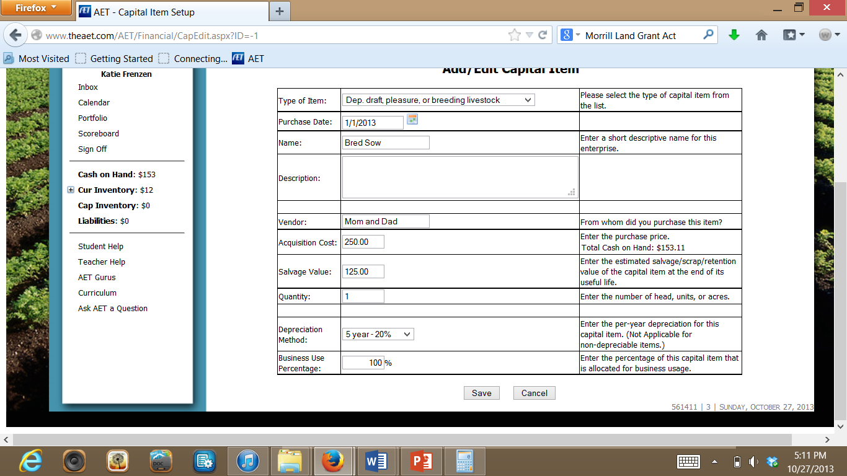

Use the Income and Expenses Charts below to record the money that Sam Husker has coming in as an income or going out as an Expense.

Any Income or Expense for Sam’s Wheat SAE, or his Swine SAE will be entered by doing the following:

1) Go to The finances tab and select “New Cash Income or Expense”
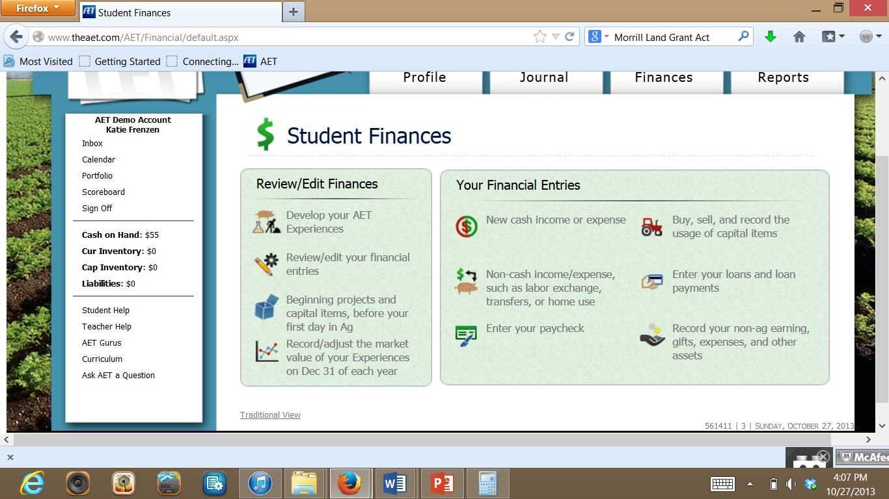

2) Select whether it is a Cash Income or Cash Expense.
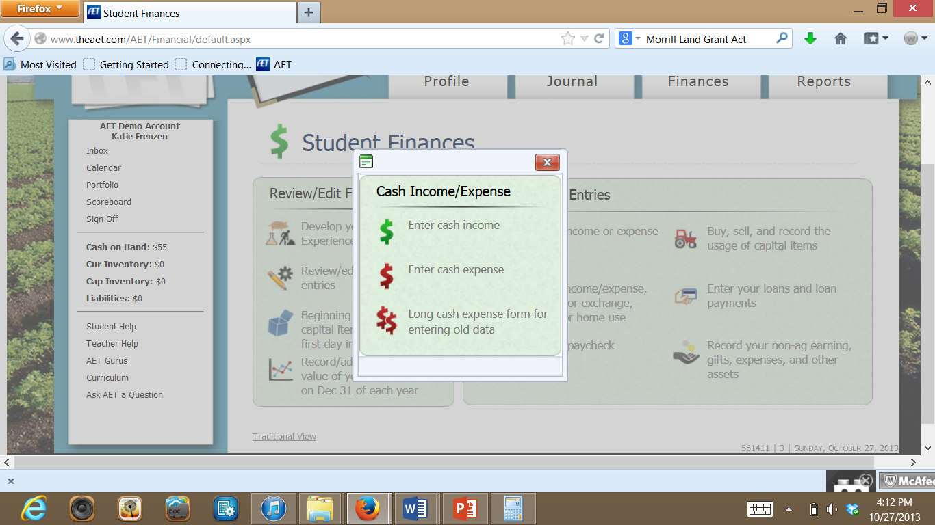

3) Select the SAE Experience in the Dropdown, what the expense/income is for, and the amount paid or received. Remember to write who you got the payment from or who you paid it to in the Vendor/Payee section (circled in red below). Then you can either save and go back OR add multiple expenses or incomes at once!

Do Not enter Taxes and Social Security withdrawals. This will be entered as an expense in the Finances tab under New Cash Income or Expense.

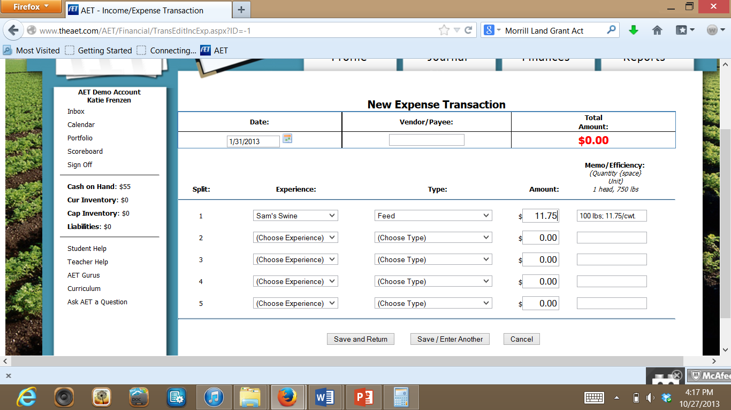

Repeat the following process for any income or expense except for Sam’s General Store Paychecks, which are entered in red in the charts below.

Any Paycheck Sam has from the General Ag Store is shown in Red in the charts below. It will be entered by clicking on: ‘Enter Your Paycheck’.

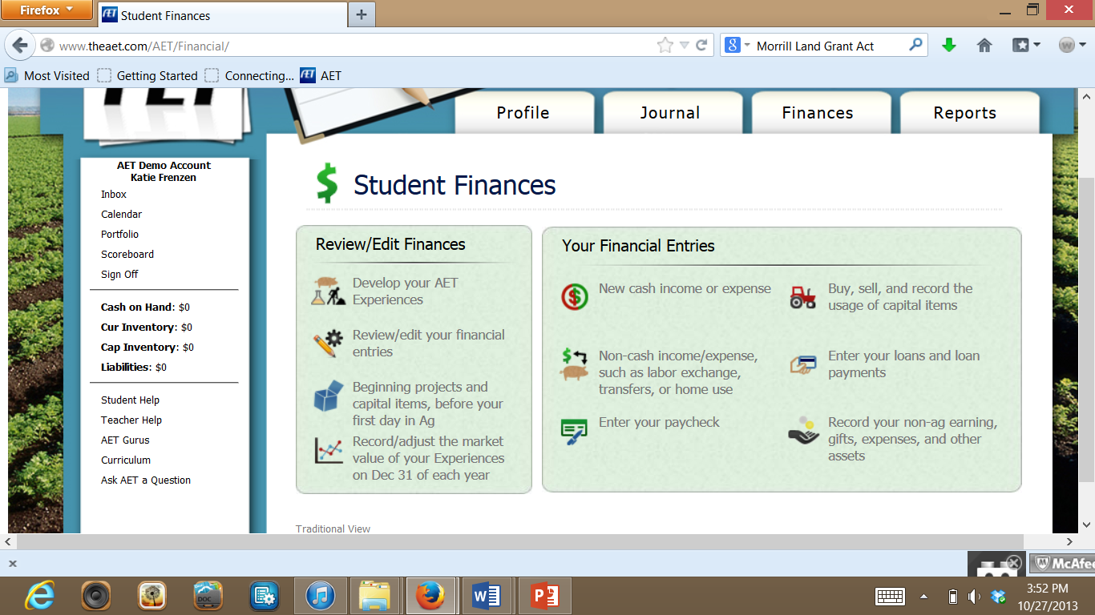

All of Sam’s Personal gifts, expenses, and income throughout the year will be recorded by clicking on record your non-ag earnings, gifts, and expenses below:

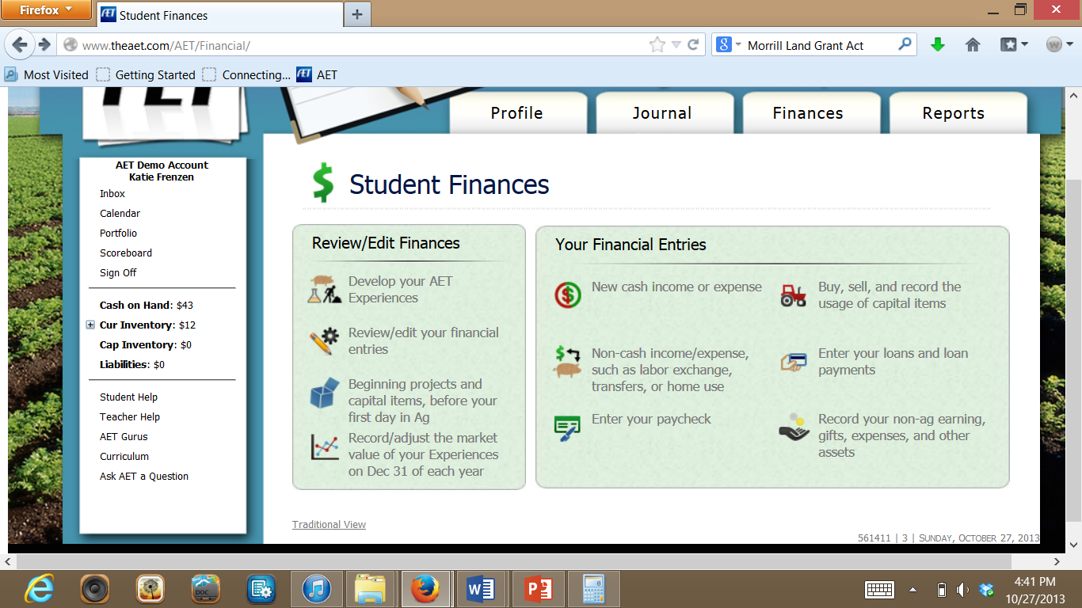

Then, enter whether it is an income or expense in the categories below. Remember to include the vendor (who it is from or paid to). For gifts, select the ‘Unearned Income’ Tab.

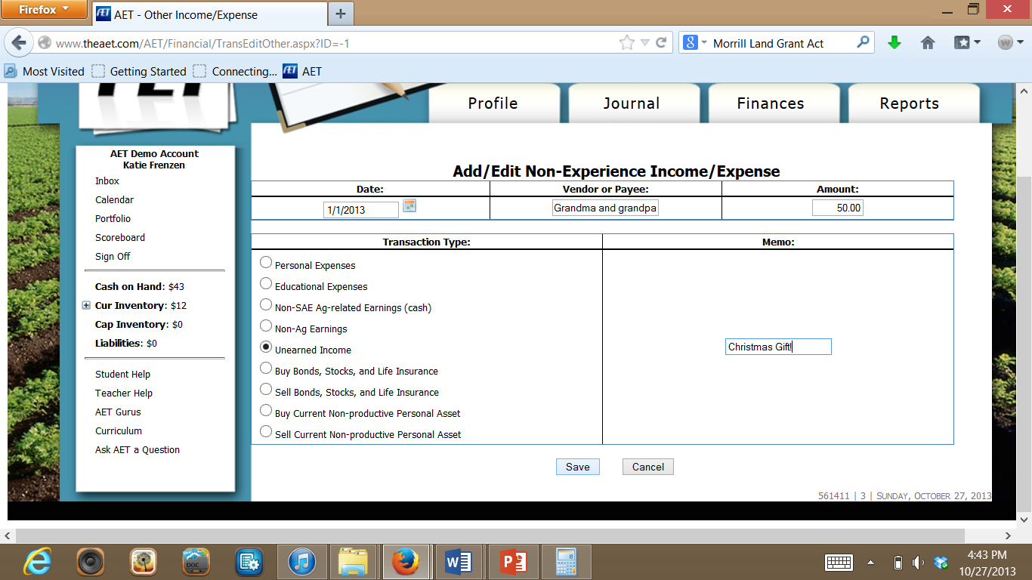

January Income and Expenses
Date | Check/Deposit | Amount | Vendor – Descriptions
Jan-1 | DP1 | 50.00 | Christmas gift – Grandparents (Henry/Harriett Husker)
Jan-10 | 101 | 8.65 | Pizza Hut – personal pan pizza and drink
Jan-20 | 102 | 13.95 | Walmart – CD (Michael Bublé)
Jan-31 | 103 | 11.75 | Coop – Sow feed 100 lbs @ $11.75/cwt

February Income and Expenses
Date | Check/Deposit | Amount | Vendor – Descriptions
Feb-1 | 104 | 3.95 | Dairy Queen – DQ Special Meal
Feb-12 | 105 | 20.00 | FNB – CASH – Tickets for Valentine’s Dance
Feb-20 | 106 | 150.00 | Sam Smith – New Farrowing Crate
Feb-26 | DP2 | 60.00 | Jim Hughes – Hauled hay (10 hours @ $6.00/hr)
Feb-28 | 107 | 41.00 | American Eagle Clothier – New button-down shirt

HINT: Anytime Sam works for Jim Hughes, this will be entered as a personal income, so you will enter it here also. When Sam works for Jim Hughes, select the Non-SAE Ag-Related Earnings (Cash) option.

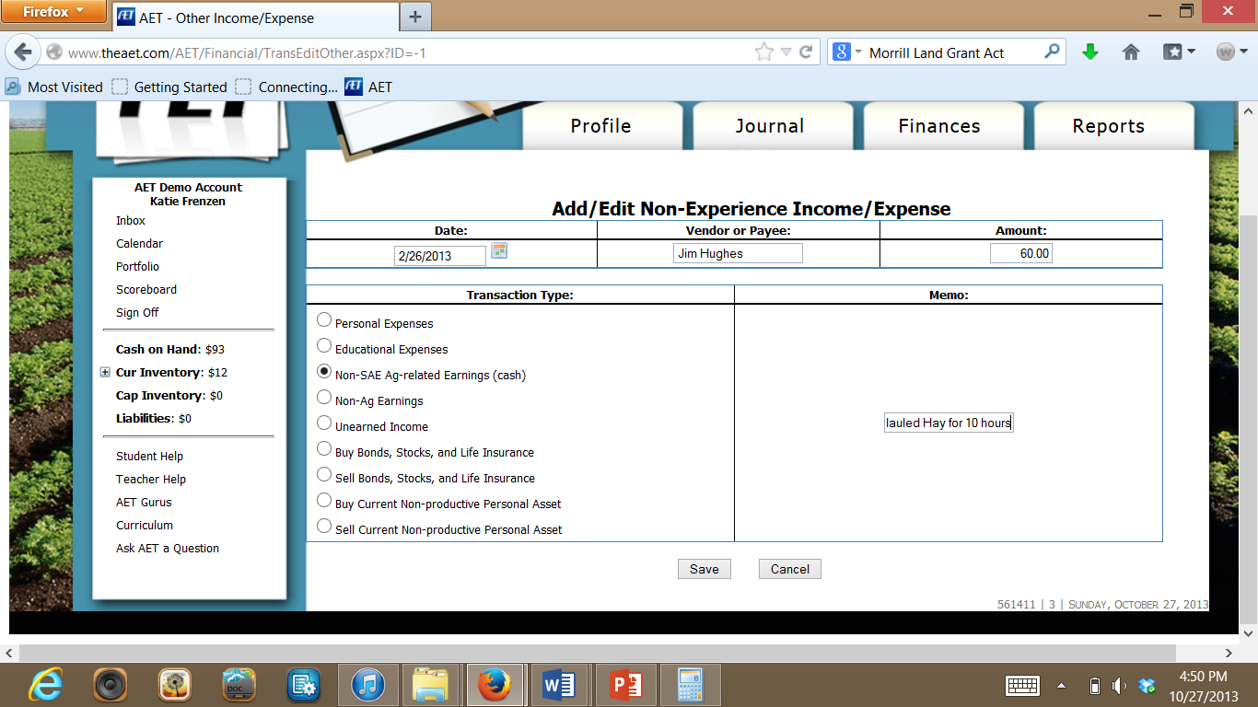

March Income and Expenses
Date | Check/Deposit | Amount | Vendor – Descriptions
Mar-10 | CASH | 14.00 | Plaza Theatre
Mar-11 | 108 | 8.95 | Vet Service and Supply – 100 cc iron for pigs
Mar-11 | 109 | 33.50 | Coop - $24.50 – Sow feed 200 lbs @ $12.25/cwt  $9.00 – Pig starter 50 lbs @ $18.00/cwt
Mar-20 | 110 | 6.28 | ACE Video – DVD rental
Mar-25 | DP3 | 36.00 | Jim Hughes – moved cattle for 6 hours @ $6.00/hr)

April Income and Expenses
Date | Check/Deposit | Amount | Vendor – Descriptions
April-2 | 111 | 26.95 | J.C. Penny’s – white dress shirt
April-2 | 112 | 75.00 | FNB – FFA Convention – wrote for CASH
April-10 | 113 | 20.00 | Alex White – Boar lease
April-13 | DP4 | 54.86 | Ag Supply Co – Gross $69 / 12 hours @ $5.75 per hr  Fed - $9.28  SS - $4.86
April-15 | DP5 | 304.00 | Midwest Livestock Auction – 8 feeder pigs @ $40/head  Sales commission - $16.00
April-15 | 114 | 7.00 | Bill Husker – Trucking for pigs (10 mi @ $.70/mile)
April-18 | 115 | 270.00 | Agri-Service Inc. – Fertilizer for 10 acres of wheat  Fertilizer - $200.00 / Applicator fee - $70.00
April-20 | 116 | 11.75 | Coop – Sow feed 100 lbs @ $11.75/cwt
April-25 | DP6 | 48.00 | Tom Graves – Disking – 8 hours @ $6.00/hr
April-27 | DP7 | 54.86 | Ag Supply Co – Gross $69 / 12 hours @ $5.75 per hr  Fed - $9.28  SS - $4.86
April-30 | 117 | 10.00 | “I” Club – Athletic Banquet Ticket

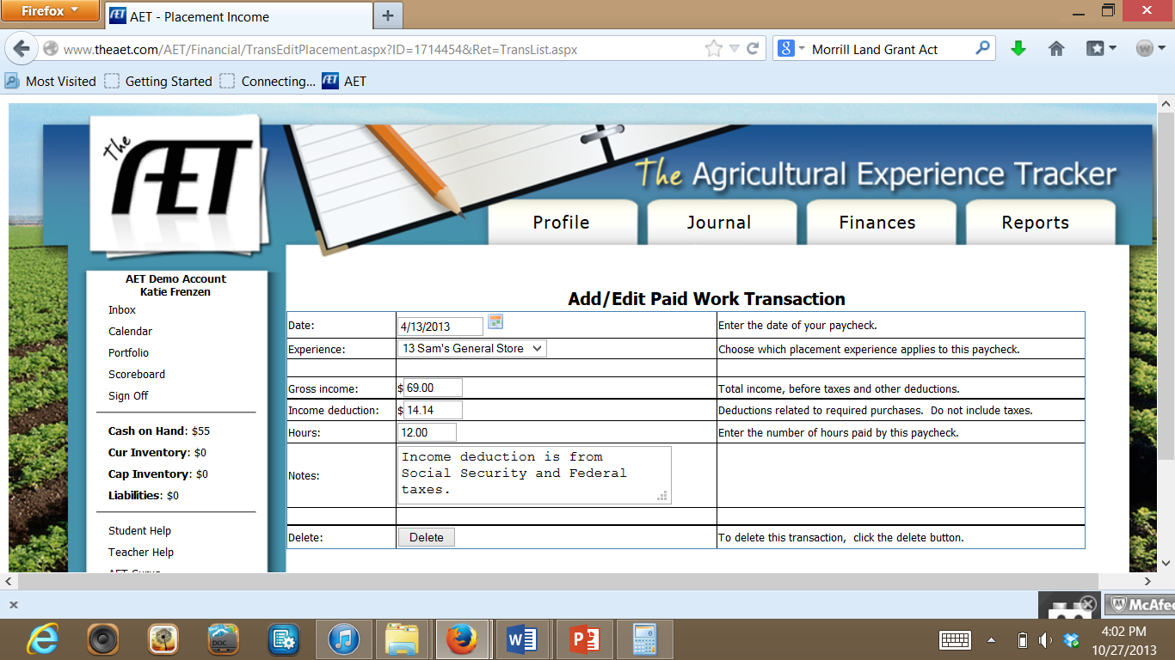
You will need to subtract the ‘Fed’ and SS amounts from your Gross Income from Sam’s work at the General Store each time before entering in the total amount paid. Fed and SS is money that is taken out of your paycheck for federal taxes and Social Security. The $14.14 from April 13 is the $9.28 for Federal and $4.86 for Social Security added together.

May Income and Expenses
Date | Check/Deposit | Amount | Vendor – Descriptions
May-4 | DP8 | 90.00 | Tom Graves – Fencing – 15 hours @ $6.00/hr
May-10 | DP9 | 69.86 | Ag Supply Co – Gross $86.25 / 15 hours @ $5.75 per hr  Fed - $11.21  SS - $5.18
May-12 | 118 | 52.60 | Walmart – Clothes (shorts, swimsuit, T-shirts)
May-25 | 119 | 75.00 | Triple Play – Baseball camp (registration)

June Income and Expenses
Date | Check/Deposit | Amount | Vendor – Descriptions
June-5 | 120 | 11.50 | Coop – Sow feed 100 lbs @ $11.50/cwt
June-12 | DP10 | 186.30 | Ag Supply Co – Gross $230 / 40 hours @ $5.75 per hr  Fed - $29.90  SS - $13.80
June-15 | 121 | 20.00 | FNB – CASH ($5.00 movie, $15.00 gas)
June-26 | DP11 | 232.87 | Ag Supply Co – Gross $287.50 / 50 hours @ $5.75 per hr  Fed - $37.38  SS - $17.25

July Income and Expenses
Date | Check/Deposit | Amount | Vendor – Descriptions
July-7 | 122 | 180.00 | Bill Husker – Combine wheat (10 acres @ $18/acre)
Jul-9 | DP12 | 1100.00 | Coop – Sold wheat (400 bushels @ $2.75/bushel)
July-9 | 123 | 11.50 | Coop – Sow feed 100 lbs @ $11.50/cwt
July-10 | 124 | 75.00 | Bill Husker – Baling straw (150 bales @ $.50/bale)
July-12 | DP13 | 232.87 | Ag Supply Co – Gross $287.50 / 50 hours @ $5.75 per hr  Fed - $37.38  SS - $17.25
July Income and Expenses (continued)
Date | Check/Deposit | Amount | Vendor – Descriptions
July-15 | 125 | 500.00 | Bill Husker – Wheat ground rent (10 acres @ $50/acre)
July-15 | 126 | 550.00 | FNB – Loan repayment ($500 @ 10% interest)  (Half interest to swine/half interest to wheat)
July-16 | 127 | 150.00 | FNB – CASH – Attend WLC Conference
July-16 | 128 | 200.00 | American Airlines – Plane ticket for WLC
July-28 |  | 1200.00 | FNB – Loan (10% interest) for 4 bred gilts - $300/each  (this will be entered in SAE Liabilities Page)
July-28 | 129 | 1200.00 | Alex White – 4 bred Yorkshire gilts ($300/each)
July-31 | DP14 | 290.40 | Ag Supply Co – Gross $360 / 60 hours @ $6.00 per hr  Fed - $48.00  SS - $21.60

August Income and Expenses
Date | Check/Deposit | Amount | Vendor – Descriptions
Aug-1 | 130 | 20.00 | FNB – cash - $15.00 gas/$5.00 McDonalds
Aug-5 | 131 | 57.50 | Coop – Sow/Gilt feed 500 lbs @ $11.50/cwt
Aug-13 | DP15 | 290.40 | Ag Supply Co – Gross $360 / 60 hours @ $6.00 per hr  Fed - $48.00  SS - $21.60
Aug-21 | DP16 | 36.00 | Tom Graves – Disking 6 hrs @ $6.00/hr
Aug-23 | 132 | 86.25 | Coop – Sow/Gilt feed 750 lbs @ $11.50/cwt
Aug-30 | DP17 | 290.40 | Ag Supply Co – Gross $360 / 60 hours @ $6.00 per hr  Fed - $48.00  SS - $21.60
Aug-30 | 133 | 85.75 | J.C. Penny’s – Clothes (pants, 2 dress shirts, underwear)

September Income and Expenses
Date | Check/Deposit | Amount | Vendor – Descriptions
Sept-5 | 134 | 115.00 | Coop – Sow/Gilt feed 1000 lbs @ $11.50/cwt
Sept-9 | 135 | 15.00 | Husker FFA - FFA dues (local, state, and national)
Sept-14 | 136 | 25.25 | Vet Service and Supply (medication for sows/gilts)
Sept-21 | 137 | 100.00 | Donation to St. Patrick’s Harvest Festival
Sept-25 | 138 | 115.00 | Coop – Sow/Gilt feed 1000 lbs @ $11.50/cwt
Sept-29 | 139 | 35.80 | Vet Service and Supply (400 cc iron for pigs)

October Income and Expenses
Date | Check/Deposit | Amount | Vendor – Descriptions
Oct-9 | 140 | 149.50 | Coop – Sow/Gilt feed 1300 lbs @ $11.50/cwt
Oct-13 | 141 | 25.00 | Date – Dinner at the Rusty Nail ($25.00)
Oct-18 | 142 | 25.25 | Vet Service and Supply (medication for sows/gilts)
Oct-21 | 143 | 15.00 | Dance tickets – Halloween FFA/FCCLA Dance (2 tickets)
Oct-25 | 144 | 149.50 | Coop – Sow/Gilt feed 1300 lbs @ $11.50/cwt
Oct-29 | 145 | 35.80 | Vet Service and Supply (400 cc iron for pigs)
Oct-29 | 146 | 49.40 | Coop – Pig Starter 250 lbs @ $19.76/cwt

November Income and Expenses
Date | Check/Deposit | Amount | Vendor – Descriptions
Nov-3 | 147 | 75.42 | Coop – Pig Grower 450 lbs @ $16.76/cwt
Nov-8 | 148 | 120.00 | VISA bill from National FFA Convention (recreation)
November Income and Expenses (continued)
Date | Check/Deposit | Amount | Vendor – Descriptions
Nov-12 | 149 | 149.50 | Coop – Sow/Gilt feed 1300 lbs @ $11.50/cwt
Nov-15 | DP18 | 2211.50 | Sold feeder pigs to Bill Husker (50 head @ $44.23/head)
Nov-30 | 150 | 42.00 | National FFA Supply Service (new FFA jacket)

December Income and Expenses
Date | Check/Deposit | Amount | Vendor – Descriptions
Dec-3 | 151 | 149.50 | Coop – Sow/Gilt feed 1300 lbs @ $11.50/cwt
Dec-9 | DP19 | 48.00 | Jim Hughes – moved cattle 8 hrs @ $6.00/hr
Dec-14 | 152 | 15.50 | Date – Movie and refreshments ($15.50)
Dec-15 | DP20 | 108.00 | Midwest Livestock Auction – sold gilt #3 as a weigh-up. 320lbs @ $37.50/cwt. Commission of $12.00.
Dec-15 | 153 | 12.00 | Bill Husker (trucking sow - 10 miles @ $1.20/mi)
Dec-18 | 154 | 77.89 | Christmas present for Mom and Dad
Dec-22 | 155 | 24.56 | Christmas present for sister
Dec-28 | 156 | 600.00 | FNB – Loan payment (50 % of loan paid – no interest)
Dec-29 | 157 | 149.50 | Coop – Sow/Gilt feed 1300 lbs @ $11.50/cwt

Other Records for Sam Husker

- Agreements – Sam will need completed agreements for his placement, livestock, and crops enterprises. This will be in the descriptions section that you did when you created each SAE.

- Hours – Enter all Sam’s hours based off his pay checks. Hours will be entered as follows:
1) Go to the Journal Tab and Click on: “Time in Your AET Experiences”.
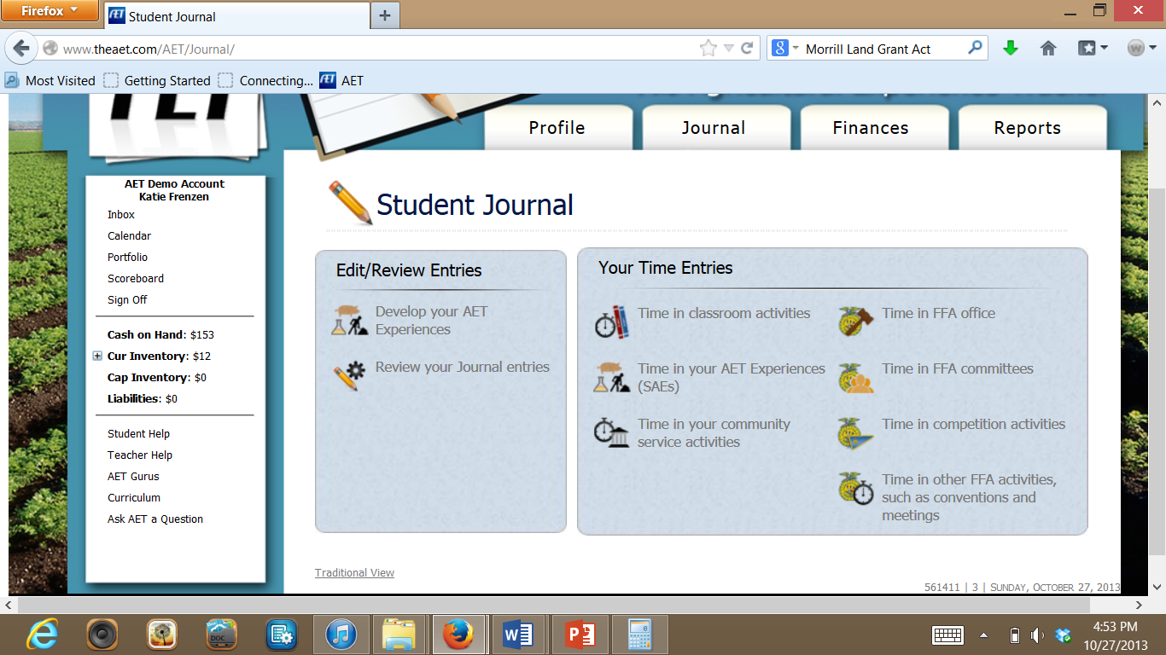

2) Add the time worked for the SAE and then click ‘Save/Enter Another’ until all hours are entered. Remember to SAVE after each set of hours you enter or it will ovverride each one!
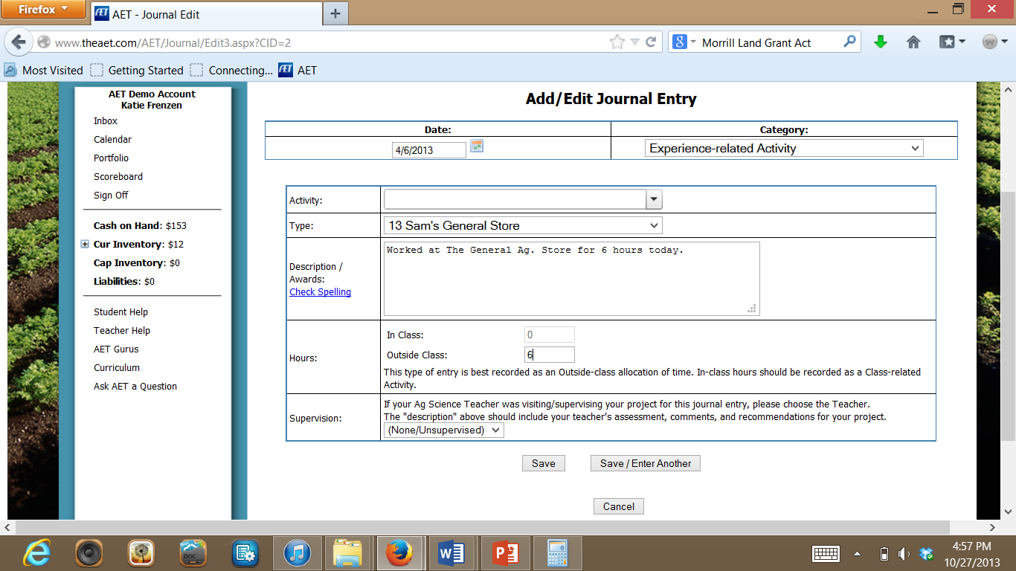

- Leadership Points: The activities listed below will be entered in the same way that you listed Sam’s hours working. However, you need to select on the right-hand side on the FFA Emblem whether it is ‘Time in an FFA Office’, ‘Time in FFA Committees’, time in ‘Competition Activities’, or ‘Time in Other FFA Activities’. Then, you will select “FFA Competition” Activity or “FFA-related activity”, etc. depending on which one relates better.
FFA Leadership Points: Select Appropriate Icon in the Square on the right hand side of screen!
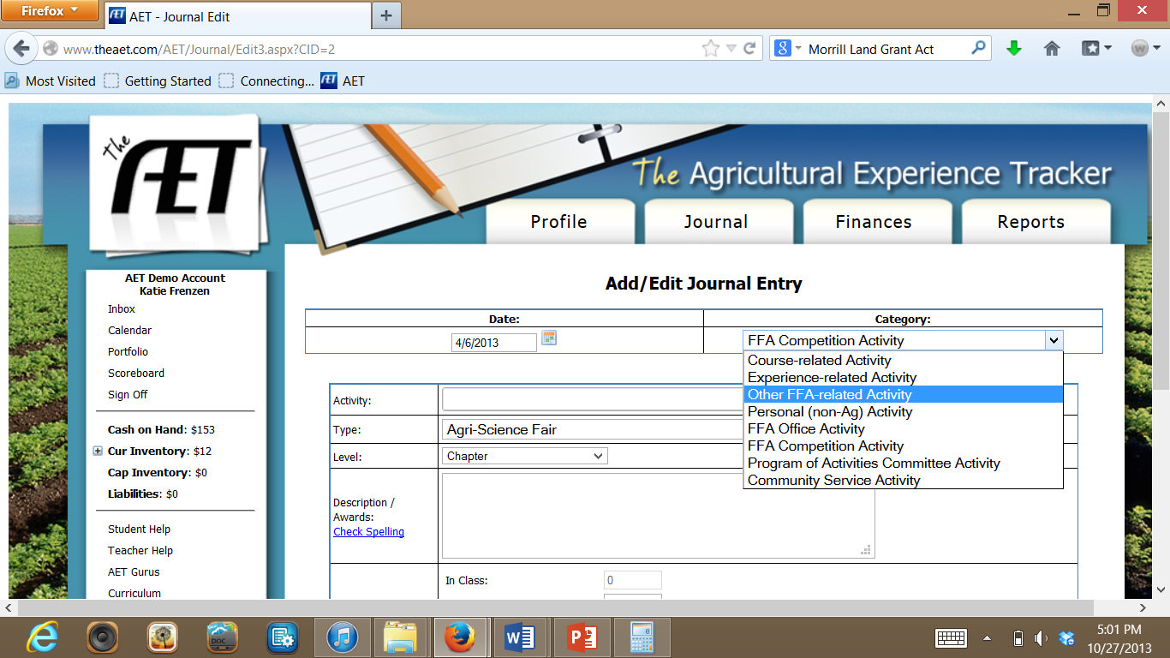

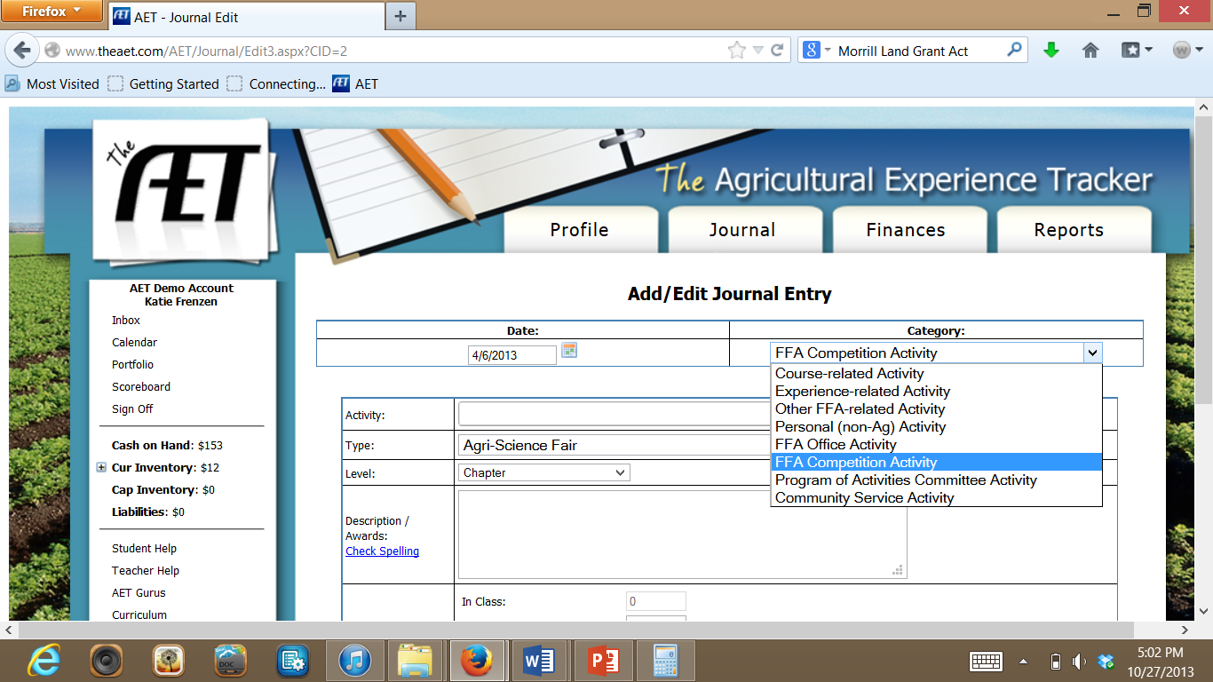

1/10 Parliamentary Procedure LSE – District – 1st Place Team
1/25 FFA Meeting – Freshmen Officers conduct Opening/Closing
2/15 FFA Meeting – FFA Banquet Planning
2/18 Floriculture CDE – District – Individual Blue Ribbon
3/15 FFA Meeting – Preparation for FFA Labor Auction
3/22 FFA Labor Auction – sold for $300 to Tom Graves
4/3 Nebraska FFA Convention – Chapter Delegate
4/3 Parliamentary Procedure LSE – State – 1st Place Junior Team
4/12 FFA Meeting – Final preparation for FFA Banquet
5/3 FFA Banquet – State President Audrey DeMarris Banquet Speaker
6/10 FFA Meeting – POA Analysis and Development for next year
6/15 Washington Leadership Conference (WLC) participant
6/23 COLT Conference at Aurora – attended in place of the Reporter
7/4 4th of July Parade – Rode on the AgEd Float during the parade
7/8 FFA Meeting – planning for the new student picnic in September
7/15 Parliamentary Procedure Team – practice for Nationals
7/22 Clean-up of the grounds at the Merrick County Fair Grounds
7/30 Parliamentary Procedure Team – practice for Nationals
8/5 FFA magazine sales meeting – planned for fall sales
9/10 Range Judging Contest – District – 2nd Place Individual
9/15 Husker Harvest Days – Setup panels to control traffic
9/20 Range Judging Contest – State – 10th Place Individual
9/26 FFA Meeting – Ice Cream Social for Freshmen students and families
9/28 Career in Agriculture Presentation – 45 middle school students
10/4 Ag Safety Day – in conjunction with Farm-City Banquet
10/15 FFA Meeting – Practice for Greenhand/Chapter Degree Ceremonies
10/27 Fruit Sales – Sold over $750 of fruit (7th place in selling for chapter)
10/28 National FFA Convention in Indy – Delegate from Nebraska
11/8 FFA Chili Feed at the opening home basketball game
11/18 FFA Meeting – Greenhand/Chapter Degree Ceremonies
11/21 Local LSI Competition – Senior Parli Pro Team
12/6 District 7 Leadership Skills – Gold Award (2nd place)
12/15 Matt Talbot Food Drive – collected 1200 lbs of food
12/16 FFA Meeting – RTC (Ready To Close) Night with Record Books

SAE Journal
The following information needs to be transferred into Sam Husker’s SAE Journal. This will be an important area to write out your hours worked and what you did while on the job.

Use the Steps Below to complete records on the Sam’s SAE Journal:
1) Click on the “Journal” Tab on AET.

2) Click “Time in Your AET Experiences.”
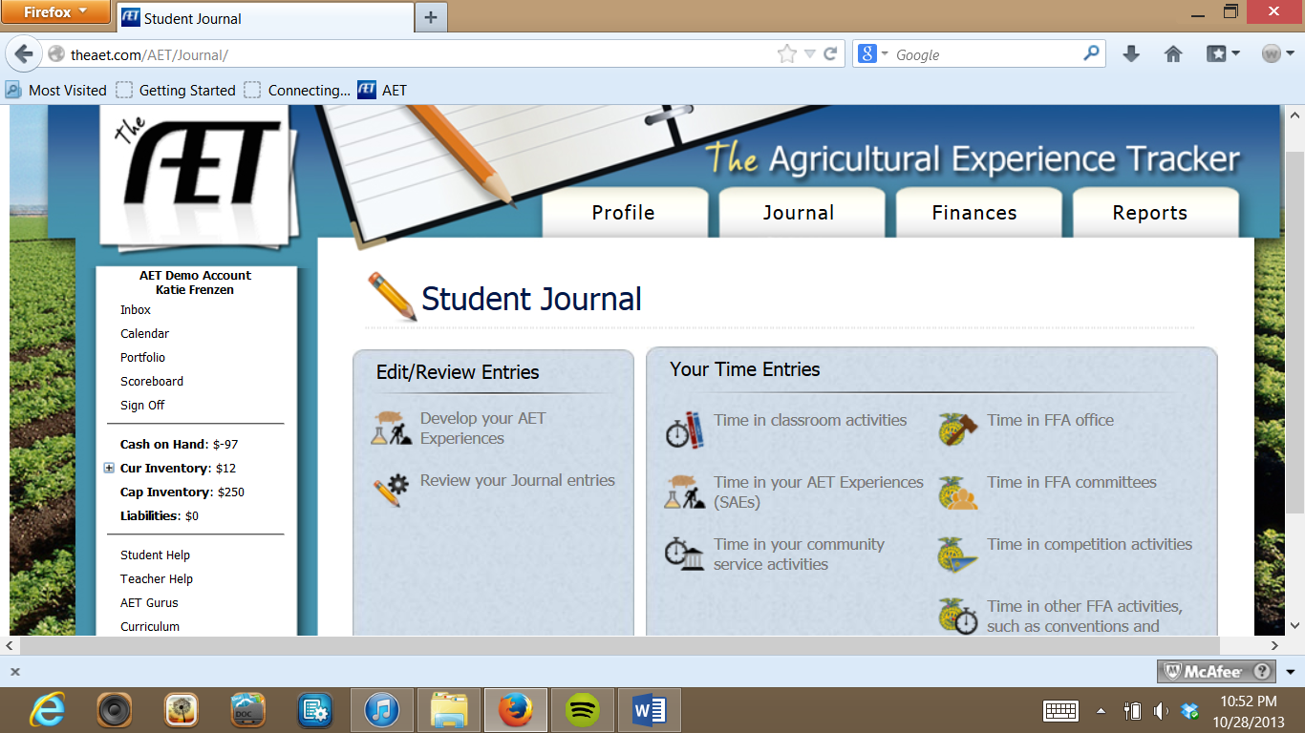

2) Indicate that is an “Experience-related Activity” in the Dropdown Box.

3) Type in the Notes & Observations in the “Activity” Box. Then, Make sure to match the SAE that the Journal Entry belongs to. Leave the Hours In Class and Outside Class BLANK.

Date | Enterprise | Notes & Observations
1/31 | Swine | Cleaned out pickup to haul sow feed from Coop
2/20 | Swine | Negotiated with Sam Smith on a new farrowing crate
3/10 | Swine | Need to remind myself to pick up iron for my pigs
3/12 | Swine | Sow farrowed. 10 nice pigs.
3/13 | Swine | Water line to farrowing crate started leaking and sprayed on the litter. Two pigs chilled and could not be revived. Water line repaired immediately.
3/25 | Personal | Helped Jim Hughes move his cattle to his pasture
4/1 | Placement | Started work today at General Ag Supply
4/10 | Swine | Turned Alex White’s Hampshire boar in with Sow #1
4/13 | Placement | First paycheck…taxes add up fast
4/15 | Swine | Watched my pigs sell at the livestock auction
5/16 | Wheat | Made arrangement for fertilizer application on wheat
5/25 | Personal | Tom Graves needed me to help with disking today
6/4 | Personal | Tom was impressed…asked me to help with fencing
6/21 | Swine | Pen mated the boar from Alex White with my Sow #1 after she came back into heat today.
6/26 | Placement | The more I work…the more I pay in taxes
7/7 | Wheat | Road a few rounds with Bill while harvesting today
7/9 | Wheat | Rich at the Coop suggested selling my wheat soon
7/15 | Swine | FNB loan repayment today…happy days!
7/17 | Swine | Applied what I learned from Animal Science Class and developed a budget for four new gilts
7/28 | Swine | Bought 4 nice gilts from Mr. White…super stock!
8/5 | Swine | Feed costs are starting to add up…need more than a pickup to haul the feed
8/21 | Personal | Tom Graves needed me to disk some more…either I do a good job or I am cheap…maybe both?
8/30 | Placement | Getting some good hours in at Ag Supply…should I consider this work as a possible career?
9/9 | Personal | Local FFA dues…remember to record the check #
9/21 | Personal | A girl I know talked me into a donation for their Harvest Festival…looked like a good cause
9/29 | Personal | Ran into Renee at Vet Service and Supply…asked her out on a date…and she said YES!
10/8 | Swine | White Gilt #1 & Gilt #2 farrowed. 11 good Hampshire cross pigs each, only one runt.
10/9 | Swine | Gilt #1 stepped on the runt through the night. Death loss at less than 10% so far.
10/12 | Swine | White Gilt #3 and #4 farrowed. 12 pigs each, not as large as the first two litters. Gilt #3 turned savage and killed three pigs called vet for suggestions he said to move the pigs away for awhile until she settled down and pour a shot of whiskey in her ear. Look at culling this gilt at weaning if weigh-up market looks good.
10/13 | Swine | Gilt #4 laid on a pig through the night
10/13 | Personal | Date went great at the Rusty Nail…need to find another job to pay for my social life
10/14 | Swine | Sow #1 farrowed. 10 awesome pigs and one deformed pig that died shortly after birth. Great litter and mothering ability -- quite the difference from gilt #3.
10/21 | Personal | Asked Renee to the Halloween Dance…YES AGAIN!
11/5 | Personal | Attended National FFA Convention…what a trip!
11/15 | Swine | Mr. Husker wanted my pigs…so I sold them to him
12/9 | Personal | Mr. Hughes needed me again today…moved cattle
12/14 | Personal | Another date with Renee…went to Ratatouille
12/15 | Swine | Sold the nasty #3 gilt. I was glad to see her go until I saw the loss I took on the weigh-up market. I can’t believe the price of sausage at the grocery store for the price I’m getting at the livestock market.
12/23 | Personal | Finished all my Christmas shopping today

Skills and Abilities: Complete this the same way you completed the SAE Journal entries. See above.

Date | Enterprise | Skill or Ability
1/23 | Swine | Calculated an estimated improvement from genetic selection based on carcass length
2/10 | Swine | Evaluated and correctly placed a class of four market swine
2/15 | Swine | Gave oral reasons for placing a previous class of four market swine
2/21 | Swine | Evaluated live market sine for USDA quality grades
3/12 | Swine | Diagramed a farrowing facility for swine
3/27 | Swine | Developed a comprehensive procedure to follow before, during, and after farrowing
4/11 | Swine | Developed a management program for specific stages of growth for market swine
4/15 | Swine | Ear notched swine for identification
4/27 | Swine | Designed a total confinement swine system
6/21 | Swine | Used pen mating to settle a sow

School and Community Activities: Enter these the same way you entered Leadership Points on the AET website, but instead, select “Personal (Non-Ag) Activity” or “Community Service Activity” Depending on what it is.

Activity/Office/Assignment | Award/ Responsibility
Played the trumpet at the Huskerville Winter Band Concert | Participant
Played JV Basketball | 2nd String Guard
National Honor Society (NHS) | Inductee
Varsity Track Meet – Huskerville Invitational | 4th Place-High Jump
Varsity Track Meet – Sooner Quad | 2nd Place-High Jump
Spring Church Clean-up | Volunteer
Kiwanis Pancake Breakfast | Volunteer
Varsity Track Meet – Cyclone Tri-State Meet | 8th Place-High Jump
FCA Awards Banquet | Setup/Clean-up
Varsity Track Meet – Conference Trials | 5th Place-High Jump
Varsity Track Meet – District Meet | 3rd Place-High Jump
Farm-City Banquet | Setup/Clean-up
Varsity Track Meet – State Meet | 10th Place-High Jump
Summer Weightlifting | Participant
Senior Summer Baseball | Left Fielder/Pitcher
Senior Summer Baseball – District Tournament | 1st Place
Senior Summer Baseball – State Tournament | 3rd Place

