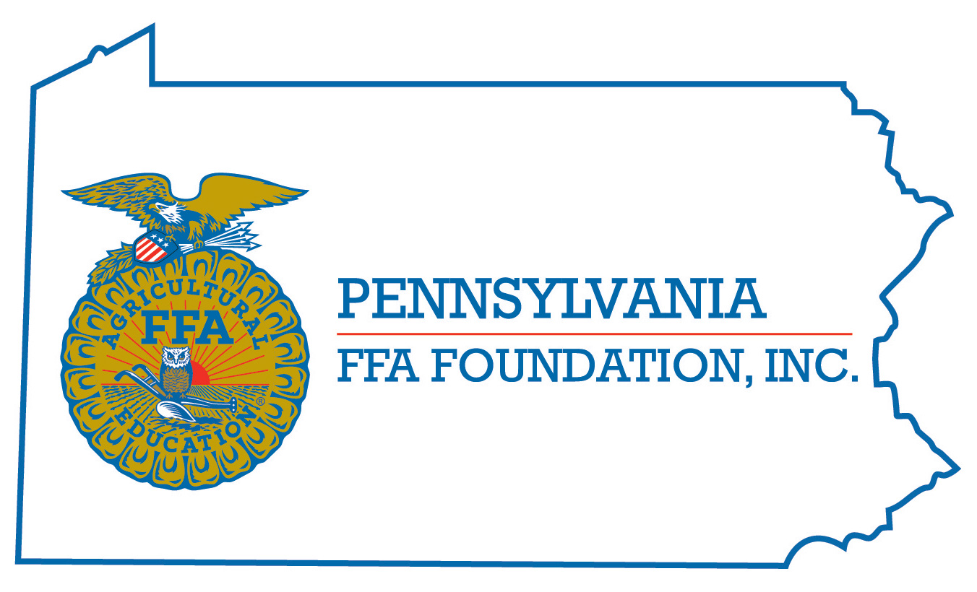
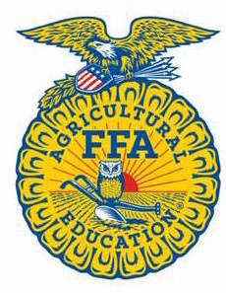
PA FFA Wildlife
Career Development Event

Chairperson Information
CDE Chairperson | Kyle Norman
Email | knorman@brockway.k12.pa.us
Best Contact Number | 814-265-8414
Contest Date/Times | June 15th at 10:00 A.M.
Contest Location | Forestry Building
CDE Review Time | If there are questions please call my cell.
CDE Review Location | N/A

Basic CDE Guidelines
Event Type: Individual/Team | # of Team Members: 0
Individual Materials List  - 2 - #2 Pencils and Eraser | Group Materials List  - N/A
Attire  - Casual School Appropriate Dress | CDE At-A-Glance (List of major components)  - Wildlife Test, Bird ID, Mammal ID, Bird Call ID, Foods ID, and Signs
Pre-State CDE Expectations
- All students with an interest in PA Wildlife are encouraged to participate.
CDE Changes from Previous Years?
- Component (tracks are incorporated in with signs), score (signs is now 20 pts not 10), and habitat evaluation (now incorporated with signs)

CDE Rules
CDE Component | Points | Component Description
Wildlife Test | 100 | This part includes 50 comprehensive questions on wildlife conservation and management.
Bird Identification | 40 | Students will identify 40 different birds found in Pennsylvania.
Foods Identification | 20 | Students will identify 20 different foods that Pennsylvania wildlife commonly eat.
Wildlife Signs | 20 | Students will identify 20 different signs of wildlife
Mammal Identification | 40 | Students will identify 20 different mammals found in Pennsylvania.
Bird Calls | 20 | Students will identify 20 different bird calls from birds in Pennsylvania.
Wildlife Tracks | 20 | Students will identify 20 wildlife tracks
Environmental Analysis | 40 | Students will complete an environmental analysis, identifying wildlife species, non-living components, construct a food web for these species, identify stages of succession and determine if this si a suitable habit - why or why not.
Non-native / introduced species | 20 | Students will identify 20 introduced / non-native species
Causes for Disqualification: Cheating and any other rule specified by the PA FFA that apply to all CDE’s.
Tie-breaker: Bird Calls then the Wildlife Test then Foods Identification if needed.

Resources
PA Game Commission “Wildlife Note Series”
PA Game Commission “A Digest of Hunting & Trapping Regulations”
PA Game Commission “Mammals of Pennsylvania”
PA Game Commission “Birds of Pennsylvania”
PA Game Commission website
Textbook - Delmar “Wildlife and Natural Resource Management”
Current Issues facing Game Commission Properties ( mineral right, wind turbines etc.)
Invite Birds to Your Home - Conservation Plantings for the Northeast, Soil Conservation Service
Shrubs and Vines for Northeastern Wildlife, U. S. Forest Service;
Peterson Field Guide to Trees and Shrubs;
The Audubon Society, Field Guide to North American Trees - Eastern Region.
PGC - Mammals of PA
Nasco Field Guide to Tracks of North American Wildlife
Peterson Field Guide to Animal Tracks
Guide to Mammals of PA by Joseph Merritt
Tracking and the Art of Seeing by Paul Rezendes.

