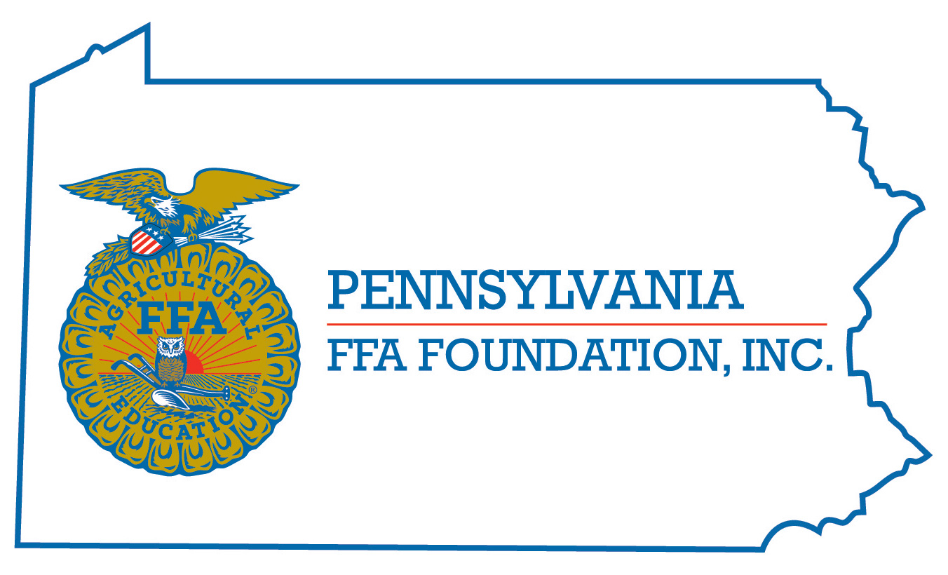
PA FFA [Title]
Career Development Event

Chairperson Information
CDE Chairperson | Gretchen L. Oberst
Email | goberst@norleb.k12.pa.us
Best Contact Number | 717-865-2117-2004 ext
Contest Date/Times | Tuesday, 1:30 pm
Contest Location | Findlay Lounge
CDE Review Time | na
CDE Review Location | na

Basic CDE Guidelines
Event Type: Chapter | # of Team Members:
Drop off book | - NA
- NA | See score card
Pre-State CDE Expectations
- Read Score card
CDE Changes from Previous Years?
- None

CDE Rules
CDE Component | Points | Component Description
Causes for Disqualification:
Tie-breaker: Chosen Categories

Resources

