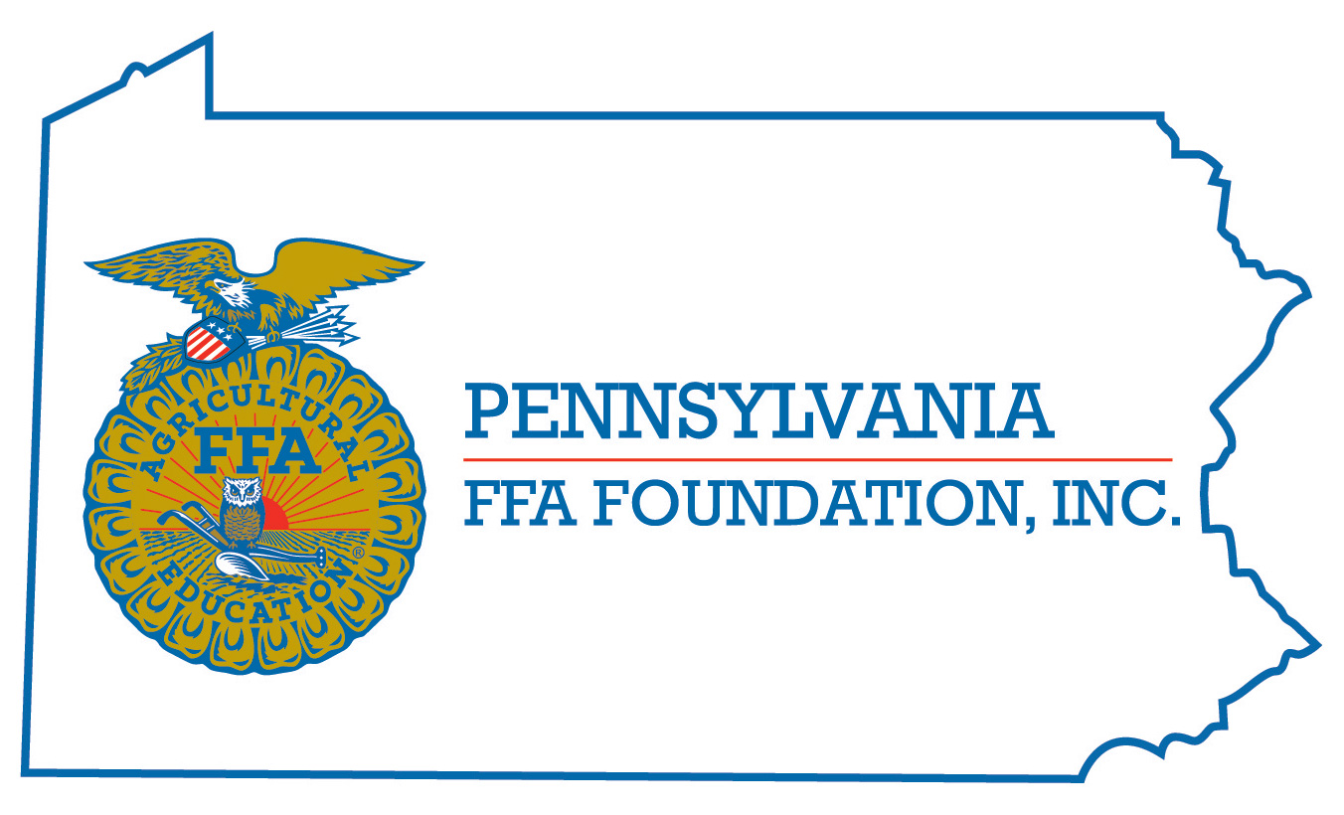
PA FFA Marketing Plan
Career Development Event

Chairperson Information
CDE Chairperson | Alexandra Barzydlo
Email | abarzydlo@doversd.org
Best Contact Number | (484) 680-8456 (cell phone – texting is an option)
Contest Date/Times | Wednesday Morning 2020
Contest Location | Penn State Assigned Classroom – Presentation Room
CDE Review Time | Presentation Review Following Event
CDE Review Location | Penn State Assigned Classroom – Holding Room

Basic CDE Guidelines
Event Type: Team | # of Team Members: 3
Individual Materials List  - none | Group Materials List  - Presentation and Display Materials  - 2 Easels provided upon request  - Projector and computer are provided
Attire  - Full, professional Official Dress | CDE At-A-Glance (List of major components)  - Written Marketing Plan  - Presentation of Plan
Pre-State CDE Expectations

- Written Marketing Plan emailed to abarzydlo@doversd.org by May 1
CDE Changes from Previous Years?

- Items must be submitted May 1

CDE Rules
CDE Component | Points | Component Description
Written Plan | 100 | A written document not to exceed 8 pages that goes over market trends, SWOT analysis, and marketing suggestions with budgetary impacts.  **Rubric from National FFA is used
Presentation | 200 | An oral presentation with visuals presented in less than 15 minutes to a panel of three judges to explain the product, trends, SWOT, and marketing suggestions as if the judges are the business client.  *(50 of the 200 points are based on a Q&A)  **Rubric from National FFA is used
Causes for Disqualification: None specific to the event. There is a 20 point deduction that may be imposed for late submission of the written plan. There also time deductions for going over 15 minutes.
Tie-breaker: Presentation judges are to individually rank the teams from 1-# based on the number of teams involved. These rankings are added to determine the winning team (low score wins). In the event of a tie, the team that had the most first place rankings from judges of the tied teams is determined to be the winner.

Resources
It is highly recommended that all participants reference the National FFA Website for materials. The Marketing Primer is an excellent resource to use and the rules and score sheets provided by National FFA are used for the PA State event. Also, Marketing Plan is filmed at Finals Hall at National Convention each year so the top four presentations in the nation are available for viewing as you prepare in any given year.

