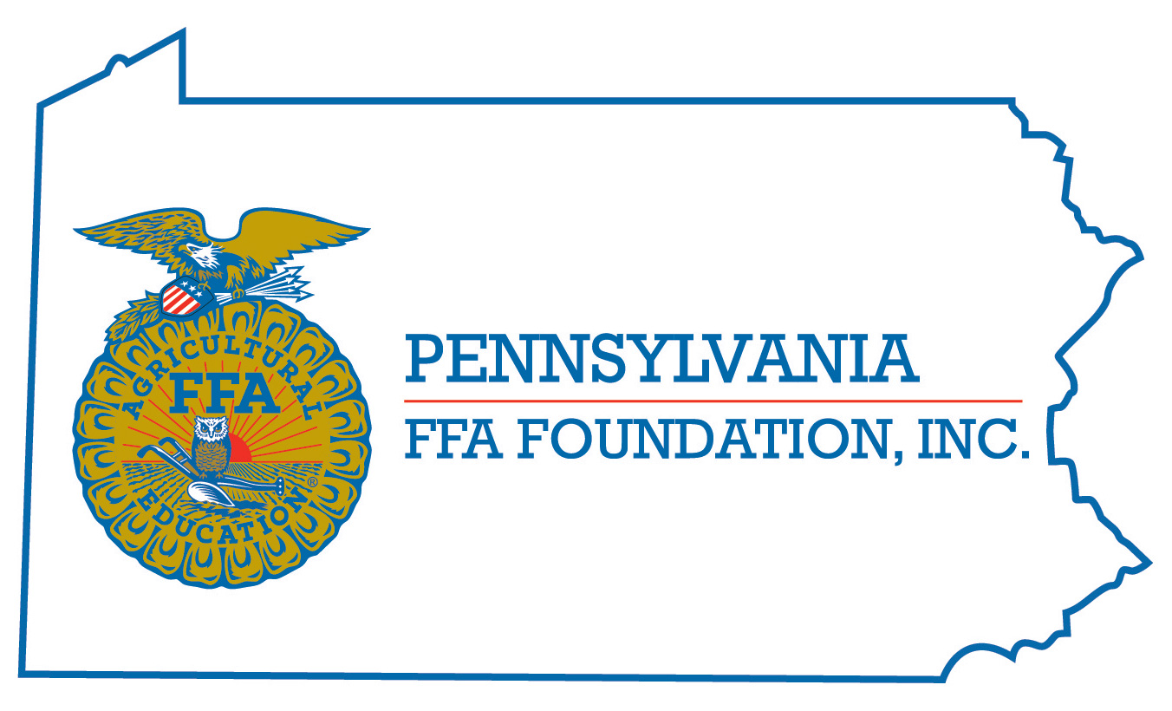
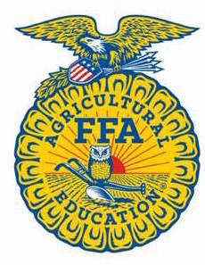
PA FFA Livestock Evaluation
Career Development Event

Chairperson Information
CDE Chairperson | Joanna McKelvey Co-Chair – Scott Myers
Email | mckelvey@wilmington.k12.pa.us smeyers@bedfordctc.org
Best Contact Number | 724-333-0601
Contest Date/Times | Tues – 2pm / Wed – 8am 2020
Contest Location | PSU Beef Sheep Center – New 2016 Reasons in ASI
CDE Review Time | At the conclusion of reasons
CDE Review Location | ASI

Basic CDE Guidelines
Event Type: Individual/Team | # of Team Members: 4
Individual Materials List  - Pen/pencil  - Clipboard  - Notepad for reasons  - Calculators | Group Materials List
Attire  - Official dress both days  - Females may wear slacks  - Closed toe shoes | CDE At-A-Glance (List of major components)  - Keep/cull  - Written test  - Marketing and genetics problem  - Evaluate 6 classes  - 2 to 3 sets of reasons  - Questions Class
Pre-State CDE Expectations
- Understand how to fill out judging cards
- Understanding of how to give reasons
- Understanding of how to read performance data
CDE Changes from Previous Years?
- Genetics and Marketing activity was added a couple years ago as per National FFA Changes. Randomly selected team members – 2 will do Genetics and 2 will do Marketing

CDE Rules
CDE Component | Points | Component Description
2 beef, 2 sheep, 2 swine | 300 | Placing Classes
2 sets of reasons (possible 3) | 100 | Reasons on specified classes
Written Test | 50 | 25 question multiple choice test
Keep/Cull – 3 class – 1 of each species | 150 | Read scenario – choose four to keep, 4 to cull
Marketing/Genetics Scenario | 100 pts each | Read and solve scenario – 1 each -2 per team on each scenario
Questions Class | 50 | Questions on a chosen class
Causes for Disqualification: Using an electronic device at anytime during competition, talking, using any resources except paper, pen or calculator for scenario completion, improper dress
Tie-breaker: to be specified the day of competition

Resources
Online CDE Exams from Nationals, From Other States or judging resources
Modern Livestock & Poultry Textbook

