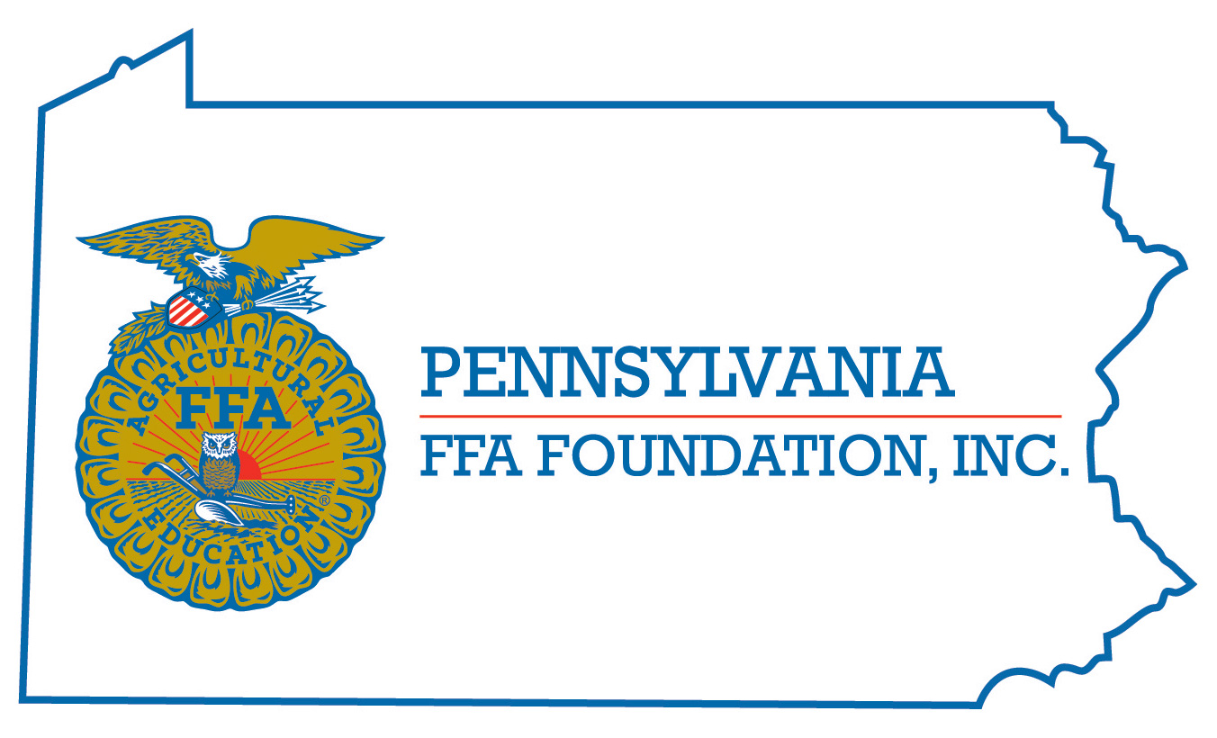
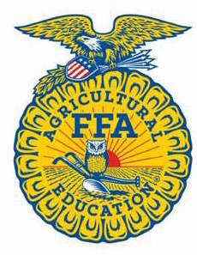
PA FFA Horse Evaluation
Career Development Event

Chairperson Information
CDE Chairperson | Mark R. Anderson
Email | mark_anderson@etownschools.org
Best Contact Number | 717-575-7217
Contest Date/Times | Tuesday, June 14, 2016 – 1:00p, (Busses depart at 12:45pm) and Wednesday, June 15, 2016 – 8:00am (Busses depart at 7:30am) 2020
Contest Location | Ag Arena
CDE Review Time | 15-20 minutes after last contestant finishes oral reasons on Wednesday
CDE Review Location | Ag Arena

Basic CDE Guidelines
Event Type: Individual/Team | # of Team Members: 4 member teams only  - all 4 scores determine team score
Individual Materials List  - 2 - #2 pencils,  - Notebook paper/portfolio for taking notes on classes | Group Materials List  - Same as individual
Attire  - Official FFA Dress both days  - No open –toed shoes on Wednesday | CDE At-A-Glance (List of major components)  - Written Exam – general horse knowledge  - 3-4 Halter Classes  - 2 Performance Classes  - 2 Sets of oral reasons (1 halter, 1 performance)  - Team Event – Problem Solving Scenario – Example topics include: marketing/current trends, animal welfare/first aid, nutrition, anatomy, management, and reproduction
Pre-State CDE Expectations
- Review the CDE Guidelines
- Make sure members are dressed properly
- Make sure members are prepared for all CDE components
CDE Changes from Previous Years?
- None

CDE Rules
CDE Component | Points | Component Description
Written Exam – 50 questions | 50 pts. | General equine knowledge – multiple choice
5-6 Judging Classes | 50 pts. each | 3-4 Halter, 2 Performance
2 Sets Oral Reasons | 50 pts. each | 1 Halter and 1 Performance
Team Event Scenario | 100 pts. | Team members work to solve problem in the scenario and present results to judges.
Causes for Disqualification: Cheating in any way, talking during exam or judging, and use of electronic device

Tie-breaker: Order for breaking ties: Written Test score, Halter Class #1 score, Performance Class #1 score, Halter Class #2 score, Performance Class #2 score.

Resources
Example of CDE Resources Include but not limited to:
4-H Horse Judging Guide. PSU, college of Agriculture Extension Service, University Park, PA.
Horses and Horsemanship. Ensminger, M. E. Interstate Printers and Publishers.
Equine Science 2nd Edition, Parker, Rick. Delmar Publishers
American Quarter Horse Association, Amarillo, TX
American Paint Horse Association, Fort Worth, TX
Other breed associations

