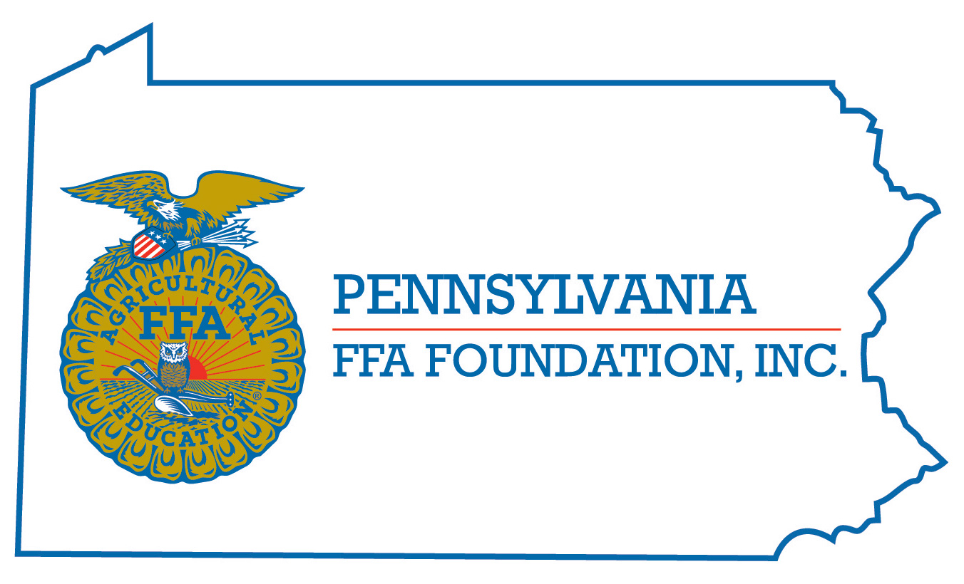
FFA Knowledge CDE
Career Development Event

Chairperson Information
CDE Chairperson | Kelly M. Bier
Email | Kelly.bier@ship.k12.pa.us
Best Contact Number | Cell – 717-860-5843
Contest Date/Times | Wednesday at 8:15 am
Contest Location | TBA
CDE Review Time | At the conclusion of the event
CDE Review Location | TBA

Basic CDE Guidelines
Event Type: Team | # of Team Members: 3 in 7th, 8th, 9th or 10th grade first year members
Individual Materials List  - The CDE will consist of a 75 question multiple choice individual test  - Questions will come from the FFA Student Handbook, Pennsylvania FFA Handbook, Official FFA Manual, www.ffa.org and www.paffa.org | Group Materials List  - The top 8 teams will come back for Jeopardy rounds.  - The team scores on the tests will be ranked to determine the seeds for the Jeopardy rounds.  - Each round will consist of a Jeopardy round, and a Final Jeopardy round.  - Each team will get 10 seconds to answer the question once they have buzzed in.  - Contestants must wait to buzz in until after the question is finished being read.  - Contestant must wait to be recognized.  - There will be no points deducted for wrong answers.  - The team can discuss the question before giving a team answer.
Attire  - Official Dress – Please refer to guidelines set by National FFA | CDE At-A-Glance (List of major components)  - Individual Test – 75 questions  - Jeopardy Rounds
Pre-State CDE Expectations
- Complete the practice questions worksheet posted on the PA FFA Website to help to study for the event.
CDE Changes from Previous Years?
- None

CDE Rules
CDE Component | Points | Component Description
Written Test | 75 | Multiple Choice & Matching Questions based on the resources, and practice questions
Jeopardy | Varies on amount earned | Teams of three students will compete against another team from a different school. They will participate in a final Jeopardy round, and will get to wager the amount of points that they wish. If they win, then they will advance in the bracket to the next level.
Causes for Disqualification: Not wearing appropriate official dress. Using cell phones during the event.
Tie-breaker: Ties on the test will be broken with predetermined test questions. Whichever individual has the most predetermined questions correct will be selected for Jeopardy rounds.

Resources
www.ffa.org
www.paffa.org
Practice Questions posted on the PA FFA Website
Sample Jeopardy Round posted on the PA FFA Website
FFA Student Handbook
Official FFA Manual

