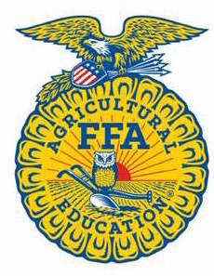
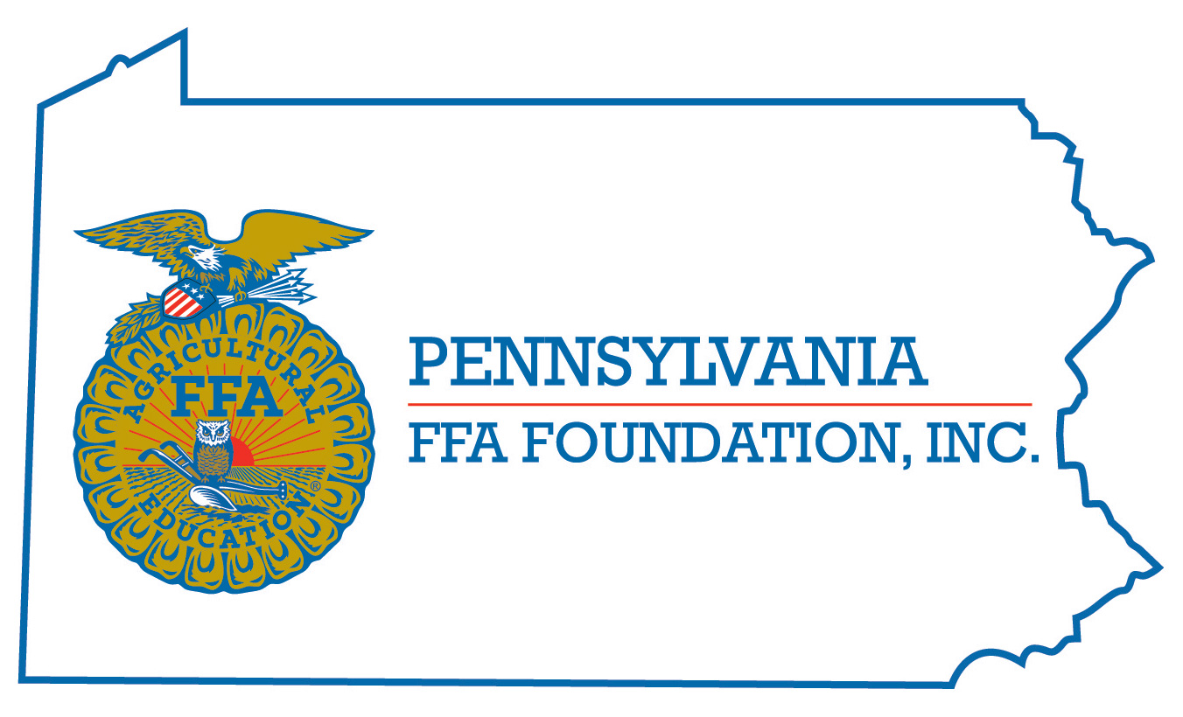
PA FFA Dairy Cattle Evaluation
and Management
Career Development Event

Chairperson Information
CDE Chairperson | Robyn Bechtel
Email | rbechtel@williamsburg.k12.pa.us
Best Contact Number | (814) 934-7133
Contest Date/Times | Tuesday: 1 – 4 On Campus  Wednesday 9 – 12 PSU Dairy Barns
Contest Location | Tuesday: On Campus  Wednesday: PSU Dairy Barns
CDE Review Time | Wednesday: Official Placings at the conclusion of reasons appx 12:30
CDE Review Location | PSU Dairy Barns

Basic CDE Guidelines
Event Type: Teams – Eligible to Move On  Individuals – State Level Only | # of Team Members: 4
Individual Materials List  Tuesday – Writing Utensil  - Optional Calculator  Wednesday – Writing Utensil  - Blank Paper  - Clipboard | Group Materials List  None – All Materials Provided
Attire  Tuesday – Official Dress  - Females may wear pants  Wednesday – School appropriate casual  - MUST HAVE Closed Toe Shoes to enter barn  - Ball Caps OKAY | CDE At-A-Glance (List of major components)  Tuesday – General Knowledge Exam  - Team Event  Wednesday – Five Judging Classes  - Two Sets of Oral Reasons
Pre-State CDE Expectations
None
CDE Changes from Previous Years?
The team scenario follows the topic rotations established by National FFA
2017 – Feeds / Nutrition
2018 – Housing / Facilities
2019 – Health / Diseases
2020 – Genetics / Reproduction
2021 – Young Stock Management

Scenarios will focus on the main topic listed for the corresponding year, but any year can ask supplemental questions about the topics listed above. Scenario can also include questions and information about animal welfare, biosecurity, business management, current issues, environmental management, and other concerns related to the dairy industry.

CDE Rules
CDE Component | Points | Component Description
General Knowledge Exam | 120 | A 40 question exam involving dairy management practices and DHIA records.  - 30 questions will cover various dairy management and industry related topics.  - 10 questions will be answered using DHIA 202 Summary Sheets.  - Participants will have 40 minutes to complete the exam.
5 Judging Classes | 250 | Five classes of four dairy animals will each be placed on type.  - Classes will be selected from the recognized dairy breeds.  - The class selection committee will give priority to selecting quality animals for the contest and is not obligated to have all breeds represented.  - Classes will consist of heifers, young cows, or mature cows.  - Participants will be permitted to view the animals from all angles but will not be permitted to handle them.  - The handlers/cattle will wear numbers which identify the animals.  - Each class is worth 50 points maximum for a correct placing.  - Participants will have 15 minutes to place each class.
Oral Reasons | 100 | Oral reasons will be required on two classes.  - The two reasons classes will be identified prior to the evaluation of the class.  - Oral reasons will be given at the conclusion of evaluating all five classes.  - The use of notes during the delivery of reasons is strongly discouraged. Points will be deducted for the use of notes.  - Each reasons set is worth 50 points maximum.  - Participants will be guaranteed a minimum of 20 minutes to prepare each set of oral reasons.  - No more than 2 minutes may be used to present reasons to the judge.
Team Activity (Teams Only) | 500  Broken as:  340 Content  80 for Presentation  80 for Teamwork | Each team will be provided with a dairy farm management scenario to identify problems and determine possible improvements.  - All necessary information will be provided, including but not limited to: Brief farm description, DHIA 202 Summary Sheet, and specific questions to answer.  - Teams should assume the role of a hired consultant advising a dairy producer (judges).  - It is not necessary to describe the scenario to the judges as they are the producer.  - Teams will be given 40 minutes to prepare their recommendations for the panel of judges.  - Teams will be allowed 10 minutes to present their recommendations.  - Judges will have 5 minutes for clarifying questions at the conclusion of the presentation.
Causes for Disqualification:
Use of cell phones during the contest
Cheating during the contest
Talking during the contest

Failure to wear official dress on Tuesday: Deduct 25 points from Knowledge Exam Score

Tie-breaker:
Individual Tie-breaker:  - Reason Score  - Individual Test Score  - Placing Totals |  |  | Team Tie-Breaker:  - Team Activity Score  - Total Team Reasons Score  - Total General Knowledge Exam

Resources
Virginia Dairy Quiz Bowl Study Materials
https://www.vtdairy.dasc.vt.edu/youth/quizbowl/youth-quiz-bowl.html
Holstein Foundation Education Workbooks and Quiz Bowl Materials
http://holsteinfoundation.org/
Hoard’s Dairyman Materials – Judging Contests, Youth Tests, Current Industry News
http://www.hoards.com/
Past National FFA CDE Materials
https://www.ffa.org/

