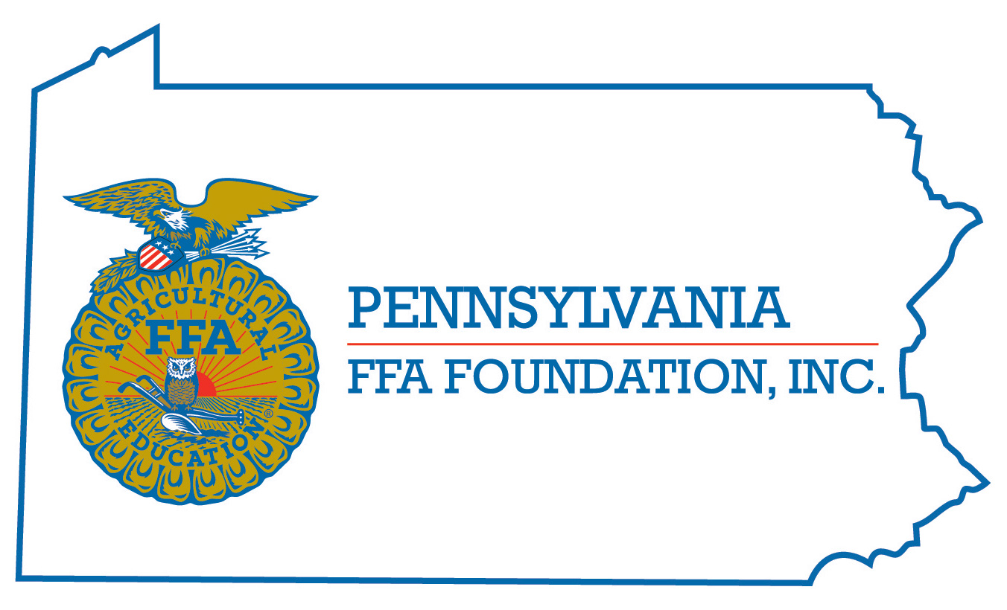
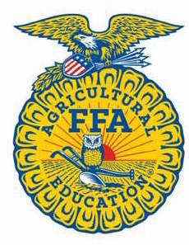
PA FFA Dairy Handling
Career Development Event

Chairperson Information
CDE Chairperson | Darla Romberger
Email | dromberger@cvschools.org
Best Contact Number | 570-617-8074
Contest Date/Times | June 12, 2024 @ 9:00 am
Contest Location | Dairy Cattle Barns-University Park, PA
CDE Review Time | 12:30 pm
CDE Review Location | Dairy Cattle Barns

Basic CDE Guidelines
Event Type: Individual | # of Team Members: 0
Contestant Requirements:  - Previous experience showing dairy heifers/cattle at county/regional/national shows  Items to Bring to Contest:  - Showmen must wear “Show Whites” to the contest  - Showmen must wear closed-toe shoes to the contest (boots are recommended) | Contest Chair will provide:  - Show Harnesses  - Show Halters  - Scorecards  - Bottled Water between rounds
Qualification:
- 24 contestants will be selected to participate based on years of experience, grade, etc.
- Submit the Dairy Showmanship Application via email to DRomberger@cvschools.org by 11:59 pm on May 1, 2024.

CDE Rules
CDE Component | Points | Component Description
Appearance of Showman | 15 | Contestant must wear professional show whites
Control of animal by showman | 20 | Contestant must provide eye contact, Mannerisms, Gestures and Poise to judge while showing animal with confidence
Poise and calmness of showman | 25 | Contestant must provide calm mannerism while showing
Skill in Showing | 40 | Ability to properly show dairy cattle
Clarification for Showing Heifers:

Dairy Showmanship participants will be evaluated utilizing the Purebred Dairy Cattle Association’s 2016 Showmanship Guidelines. All showman should review the “Showing Animal to its Best Advantage” section of the document to fully understand the new revisions for showing heifers. The judging rubric will remain the same to align with the National FFA Dairy Showmanship CDE.

Causes for Disqualification: None
Tie-breaker: Score of animal four

Resources
- National FFA Dairy Handling CDE Handbook

- Purebred Dairy Cattle Association’s 2016 Showmanship Guidelines

